**Why java is not 100% pure Object oriented?**

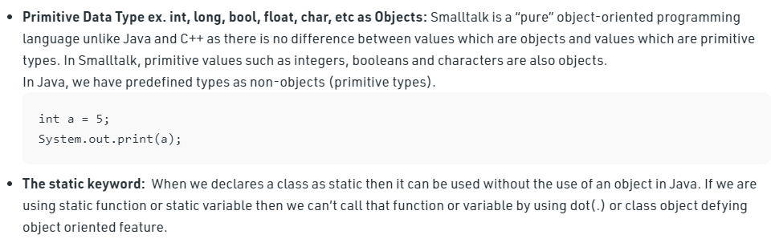

**What is history and application of java?**

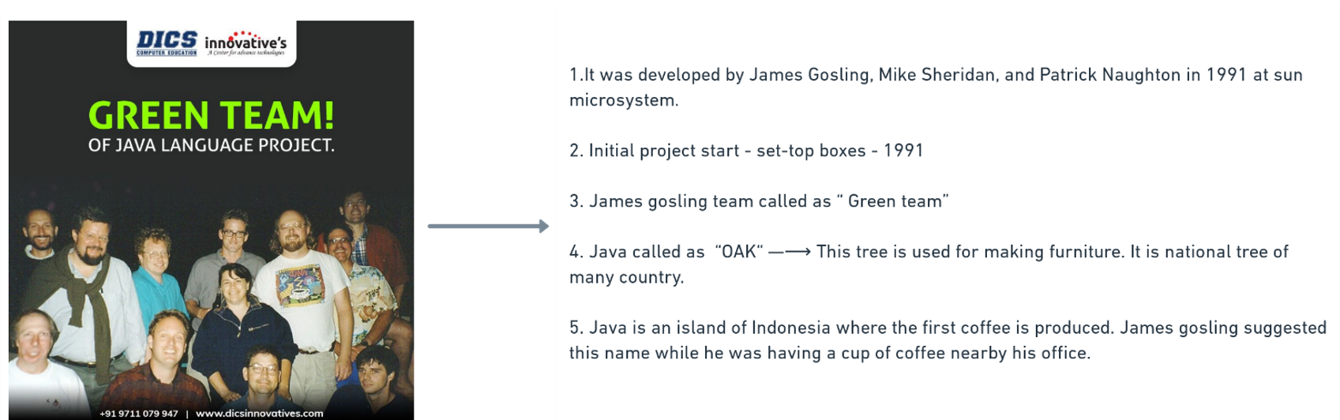

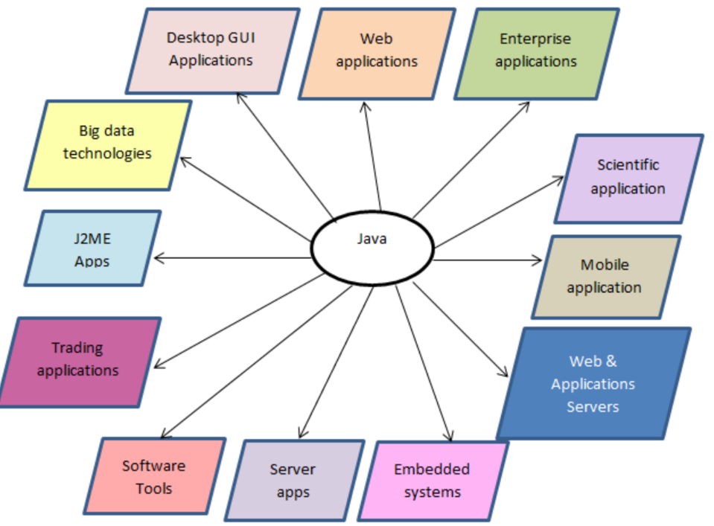

**Differences of Complier and Interpreter?**

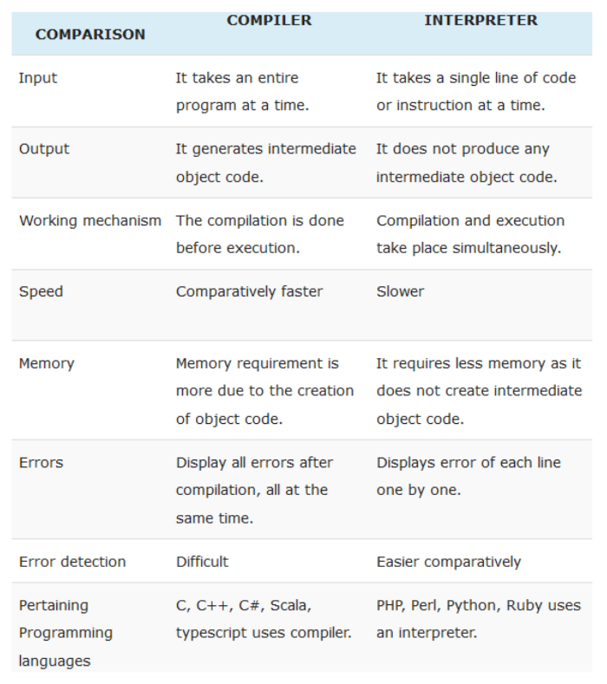

**What is JVM and How it works?**

* Jvm is platform dependent and java is platform independent
* Used to convert byte code to machine code

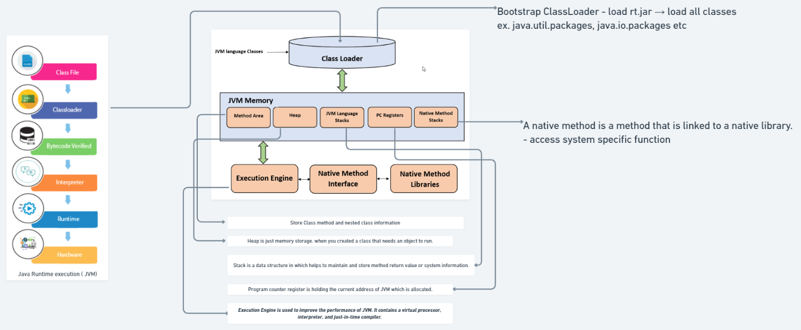

**What is differences of JDK,JRE,JVM?**

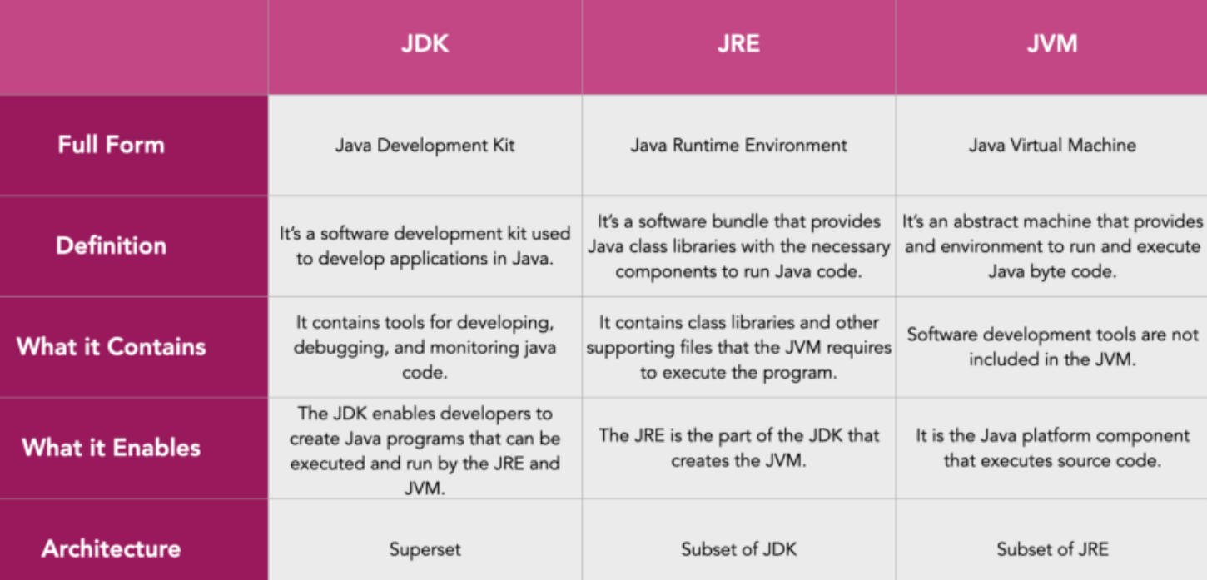

**What are features of java?**

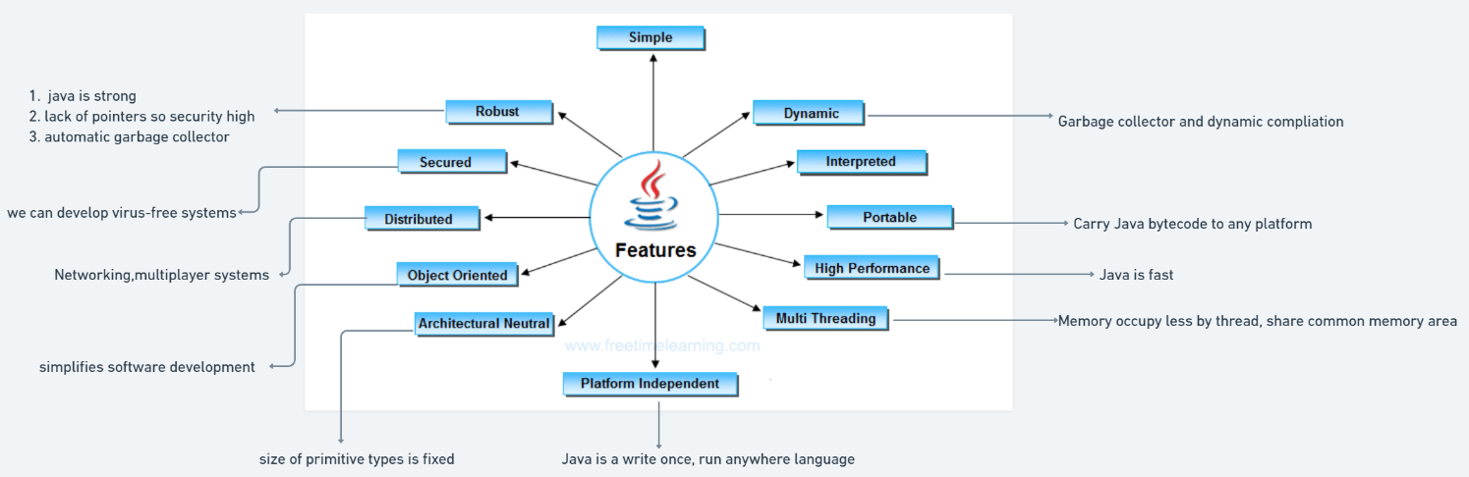

**Why main method is public and static ?**

* It is public because it is invoke by JVM and called internally.
* It is static because jvm not able create object of class so if we keep static then it is automatically called and constructor also called.

**Can we overload main method in java?**

**Yes**

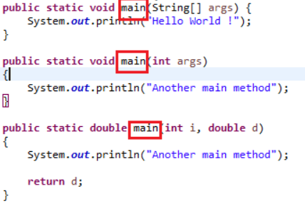

**Can we make main method as private, protected and no access modifier = No**

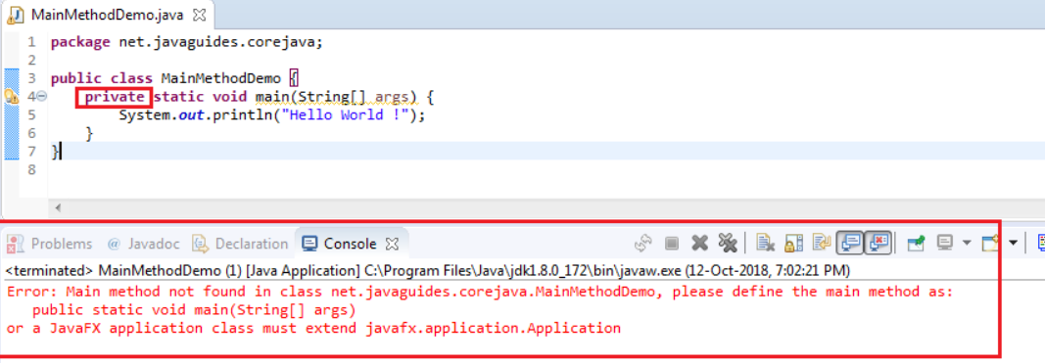

* JVM will not able access main method.

**Can we make main method as no static = No**

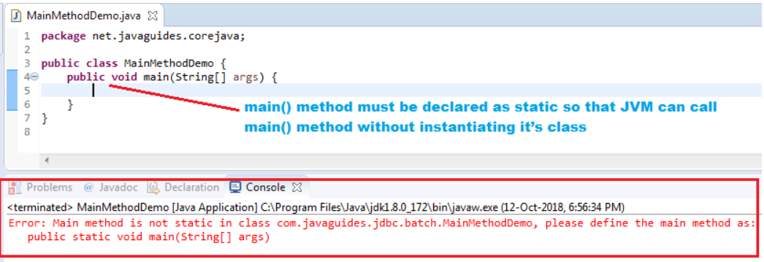

**Can we change main method return type to any = No**

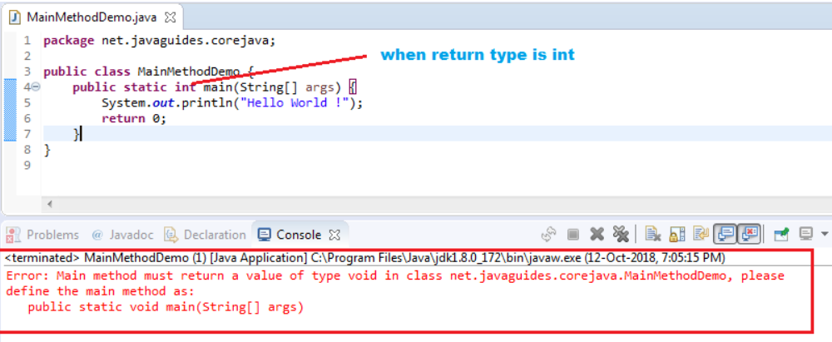

**Can we run java without main method? = NO**

but till java 6 we can use static initializer to run but java 7 onward use main method only.

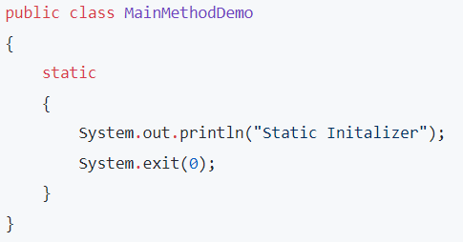

**Can we make main() as final ? = YES**

**Why java not used pointers?**

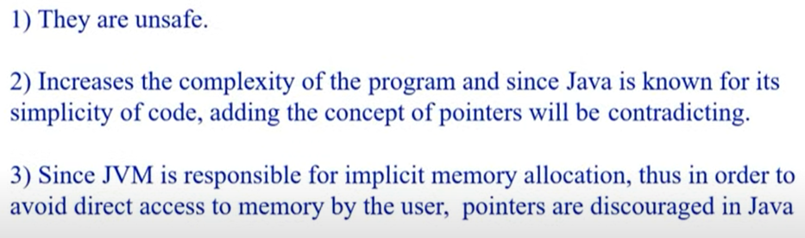

**What is JIT complier?**

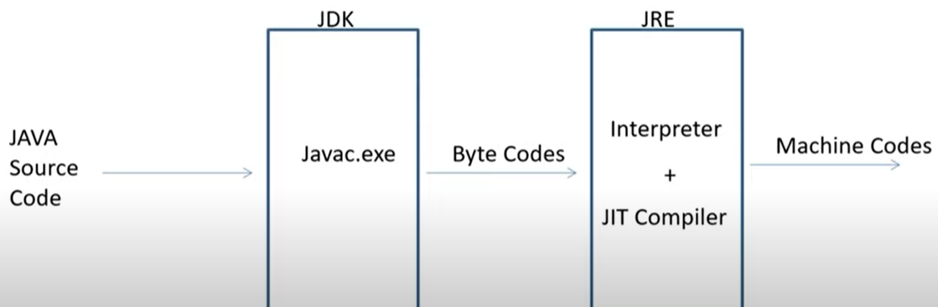

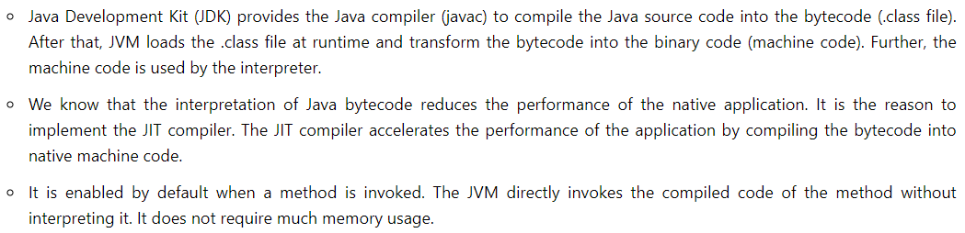

**Why String is immutable in java?**

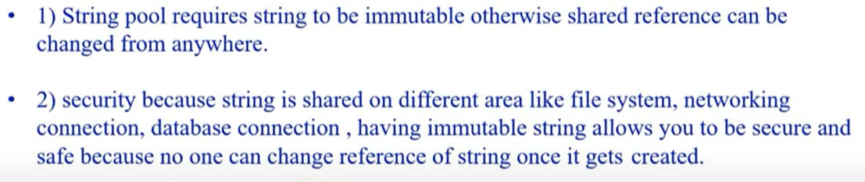

**What are ways to create string?**

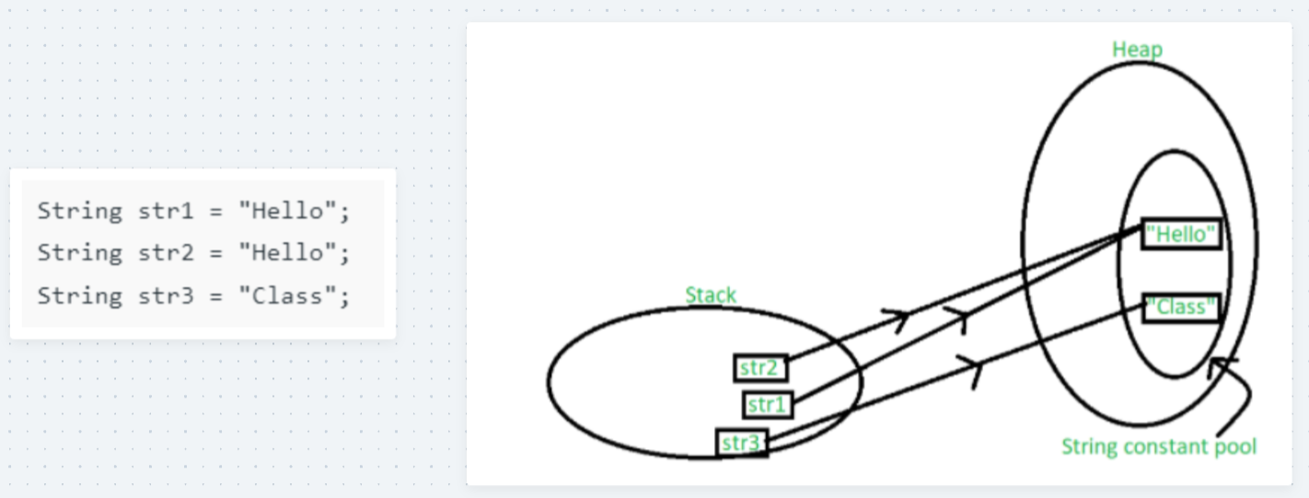

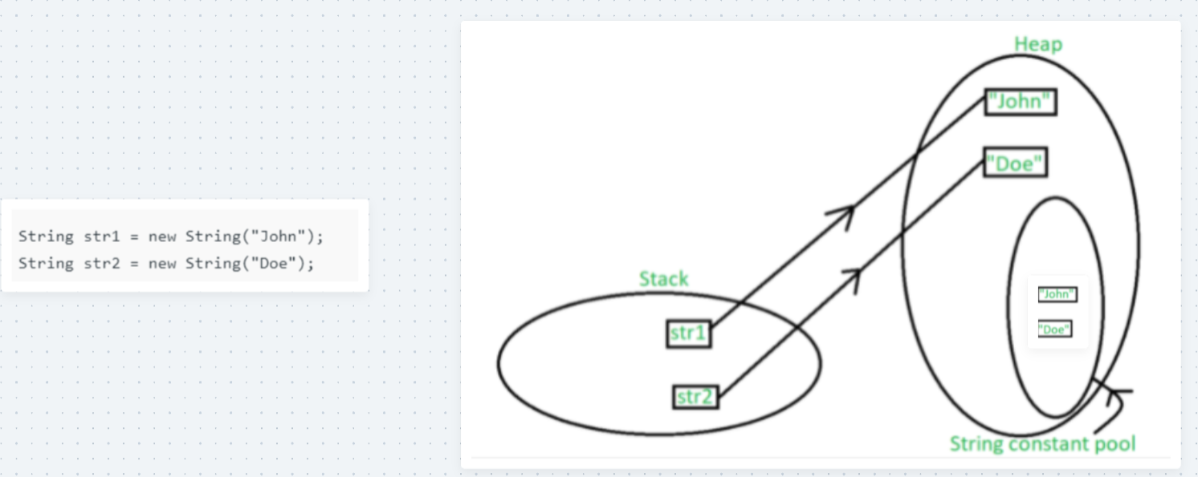

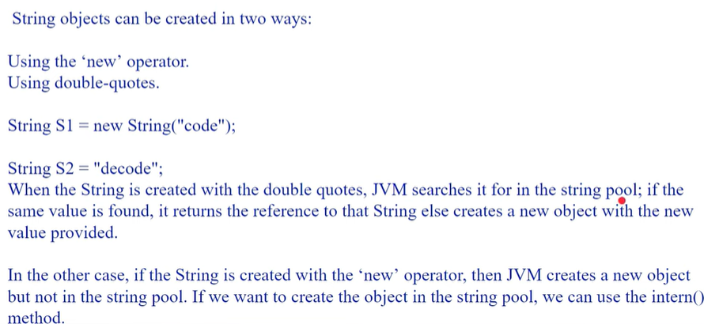

**How many objects created in following code?**

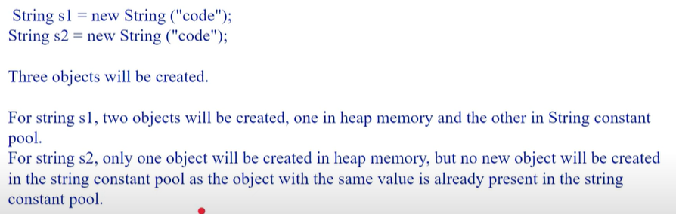

**What intern() method in string?**

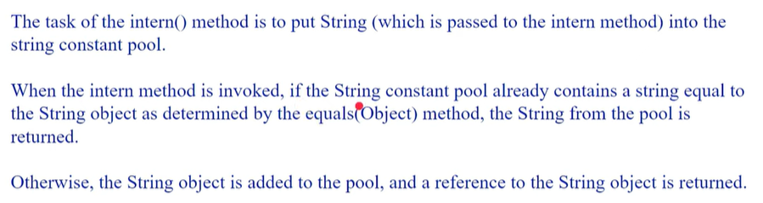

**What are differences of String & String Buffer**

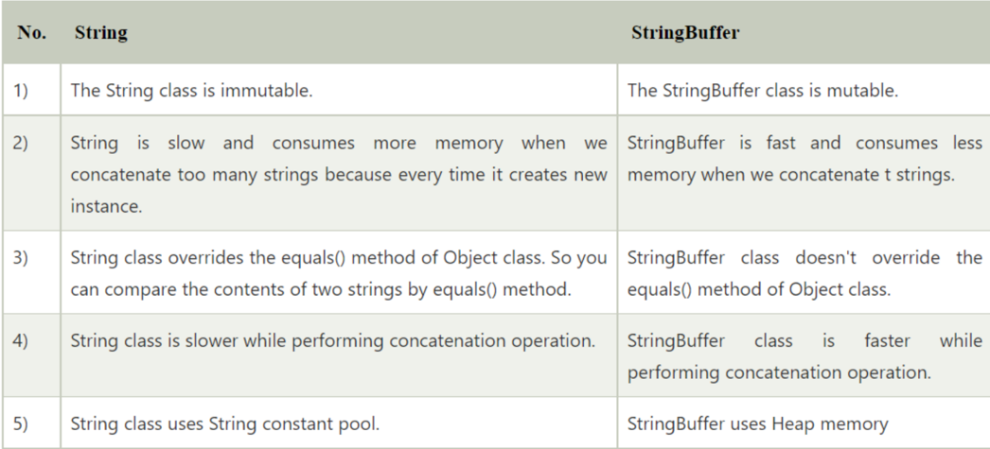

**What is differences of String buffer & String Builder**

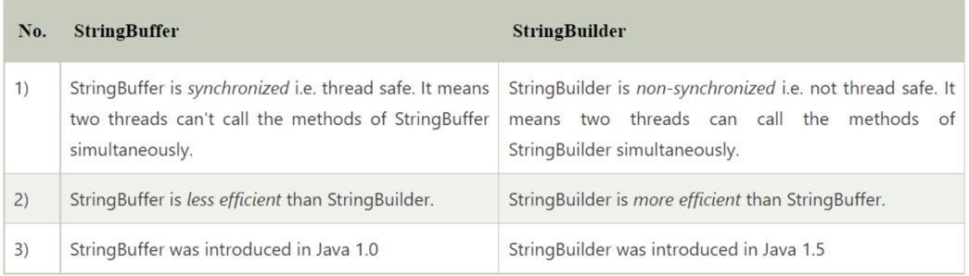

**How String Builder & String Buffer work?**

default capacity = 16

new capacity = (old capacity + 1 ) * 2;

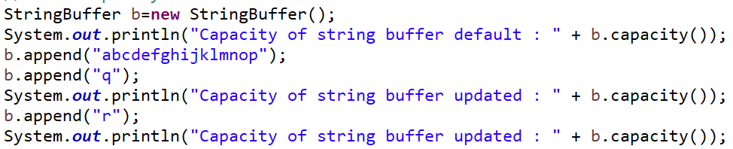

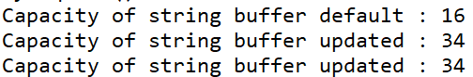

**What is String Tokenizer?**

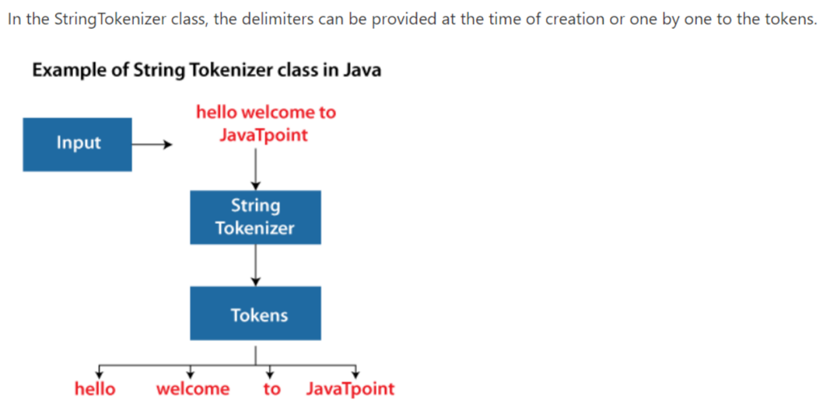

**What is String Joiner?**

It is used to construct a sequence of characters separated by a delimiter.

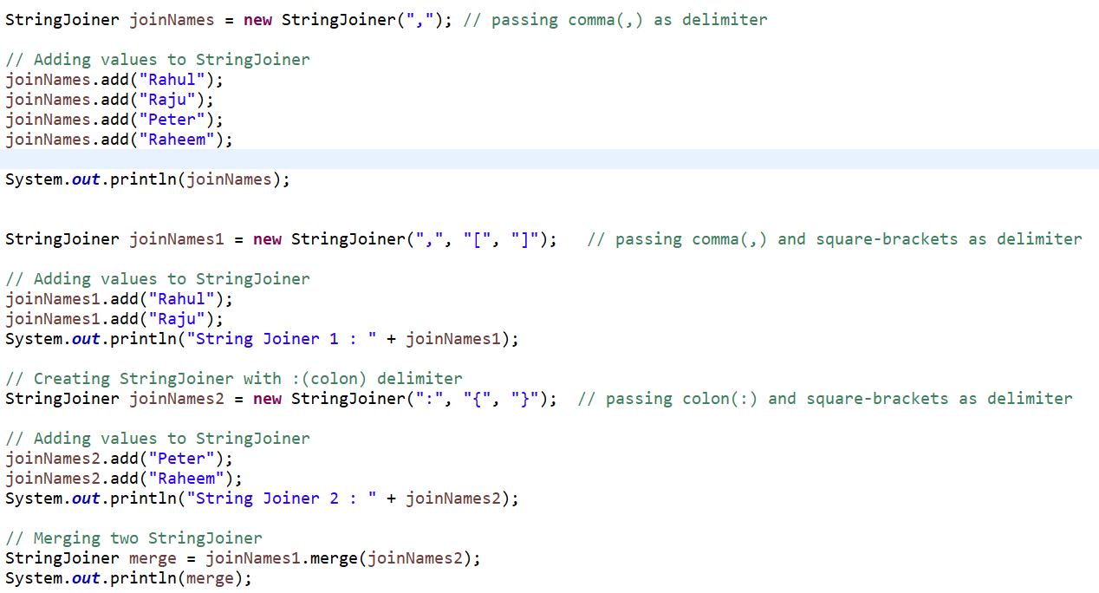

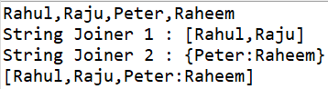

**What is Array and Advantages and Disadvantages?**

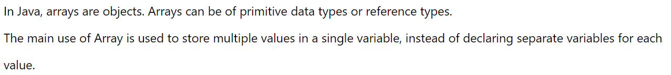





**Can Array has size as character & zero & negative?**

It will have character size, It will have zero size, it will not have negative size.

**What is Jagged Array?**

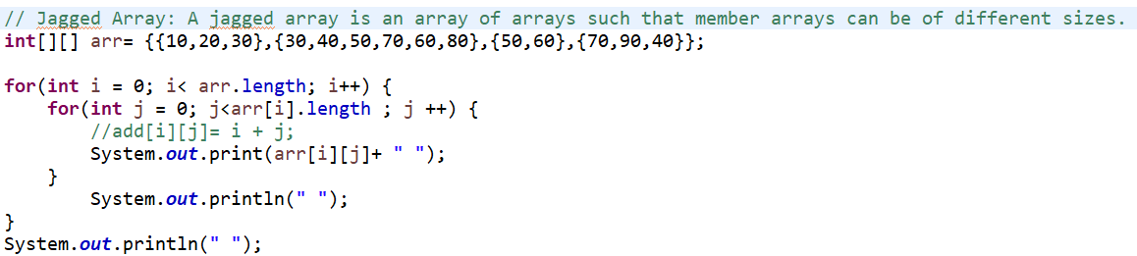

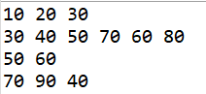

**What is Final Array?**

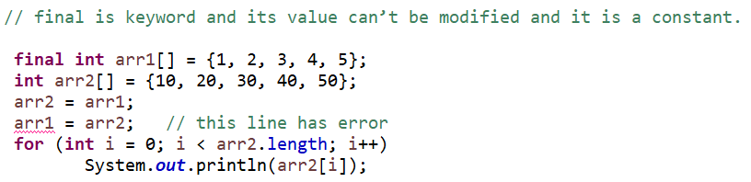

**What is Java reflection Array?**

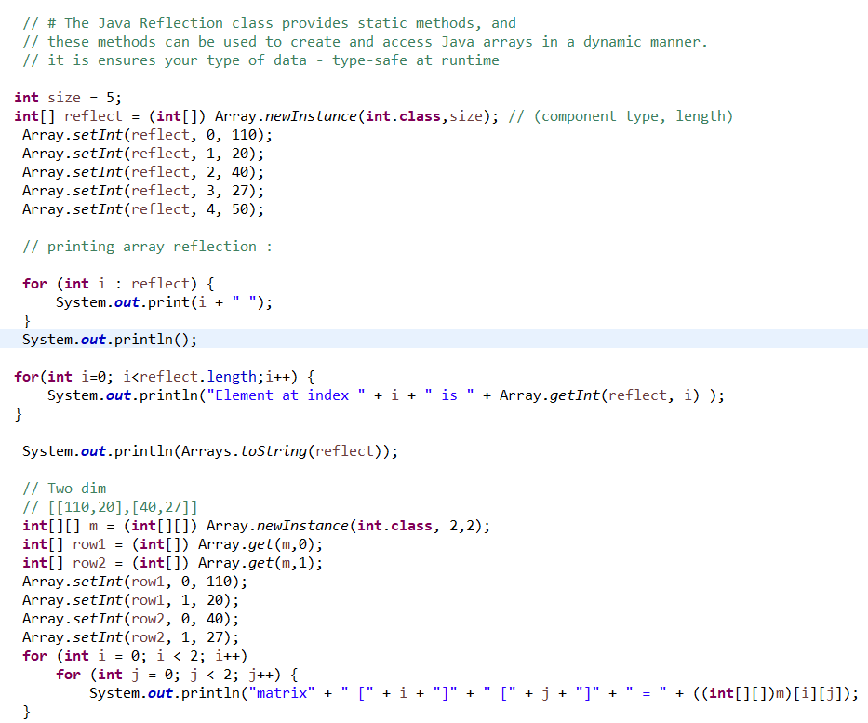

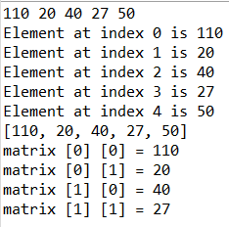

**What is Arrays mean?**

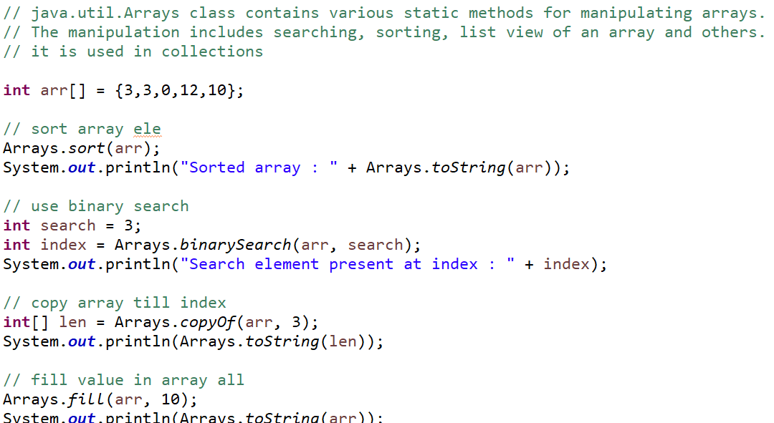

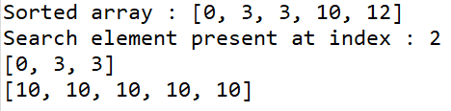

**What Is Object oriented programming and advantages?**

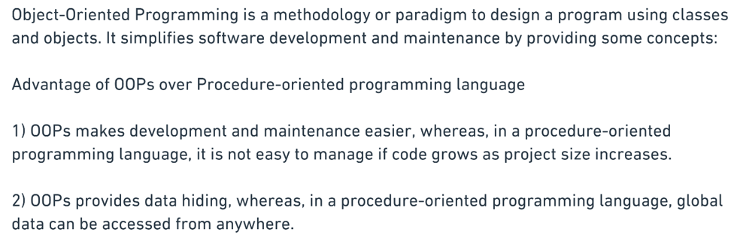

**What is class and object differences?**

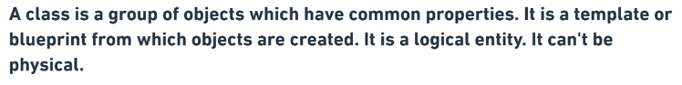

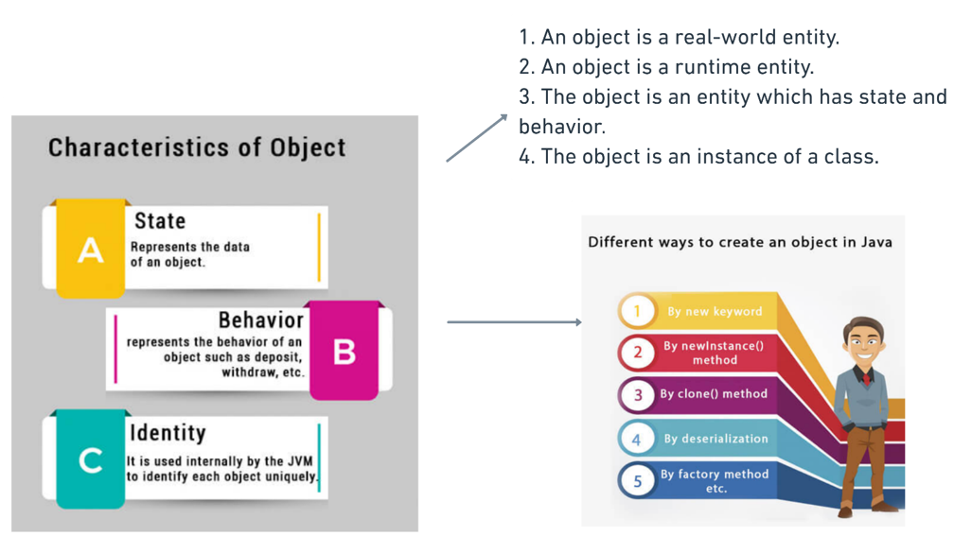

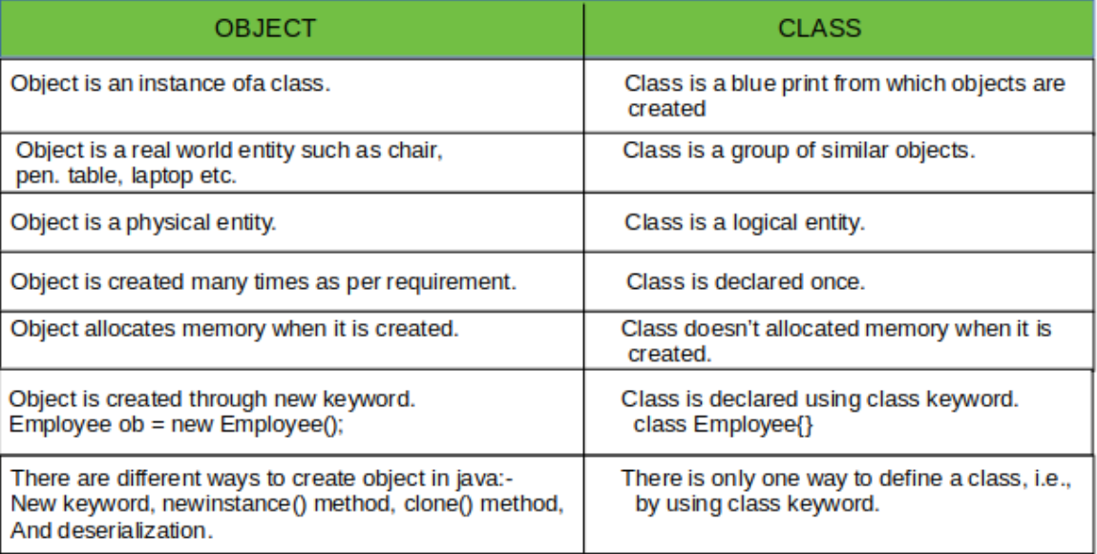

**What is constructor and why we need & Rules & Types ?**

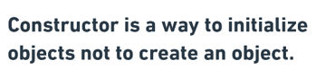

**Need :**

Let say we have student with Id and name property. initially all student has id – 0 by default but we know each student is unique and it should have unique id.

So for that something to make this id unique at time of object created. We need constructor – default or paramaterize

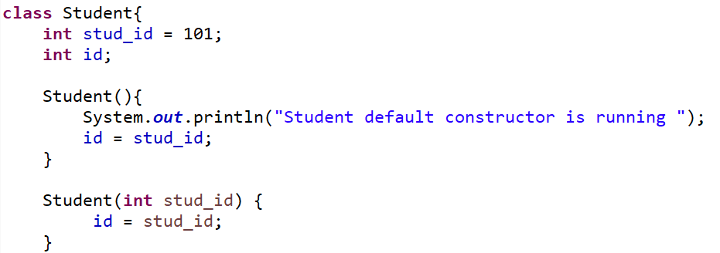

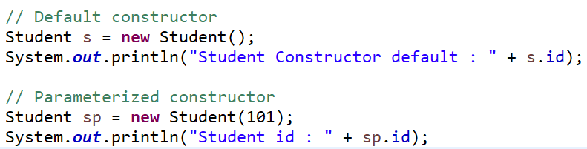

**Rule :**

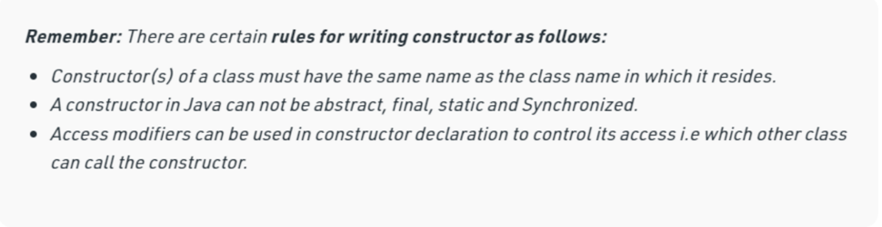

**What is copy constructor?**

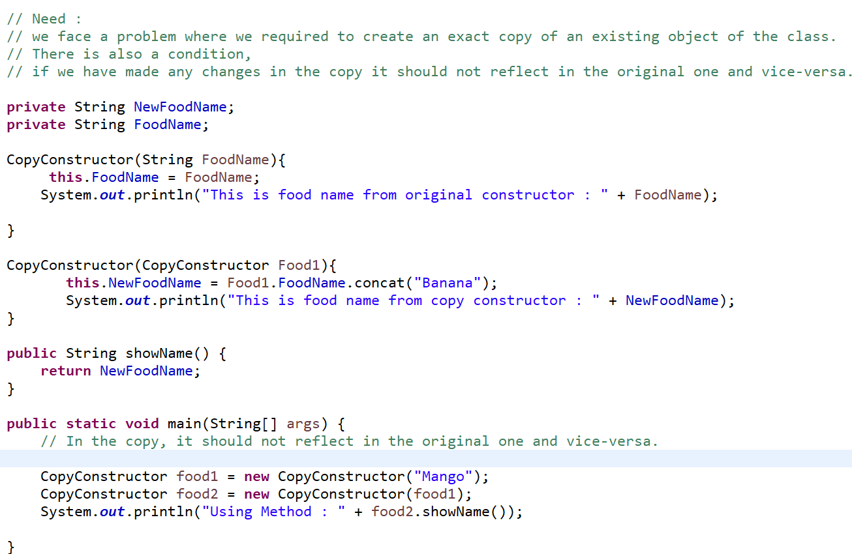

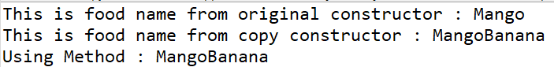

**What is Constructor Overloading?**

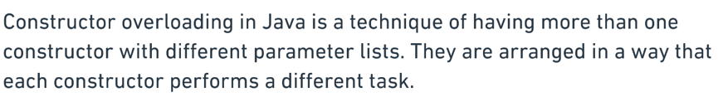

**What is Constructor Channing?**

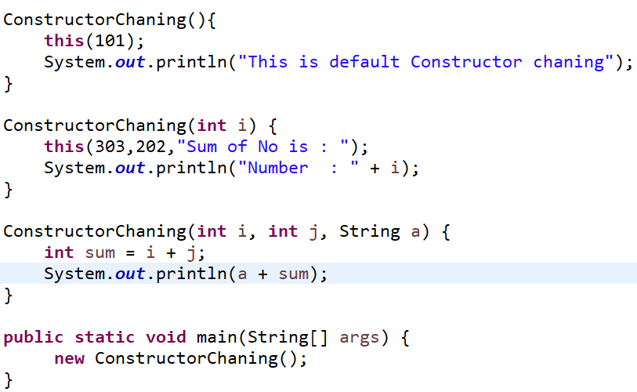



**What is this keyword & use-cases?**

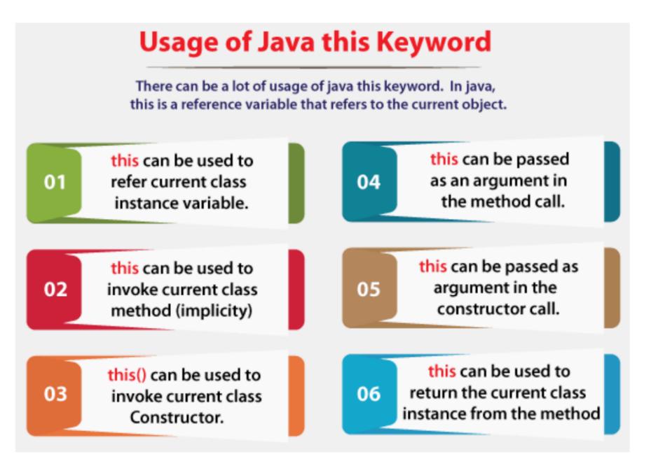

**What is Super & need?**

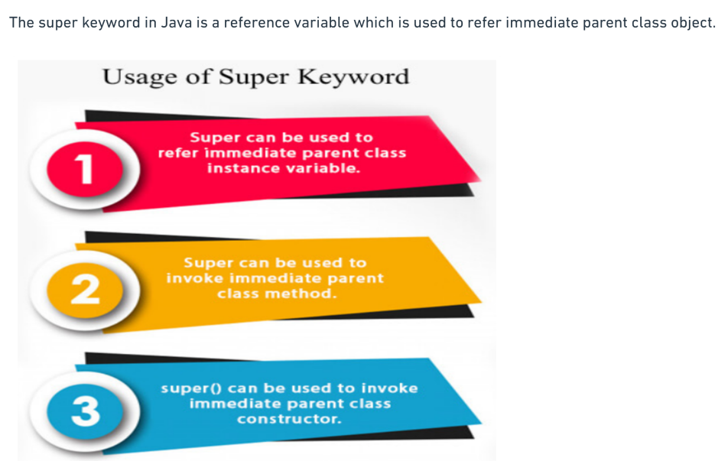

**What is inheritance and types:**

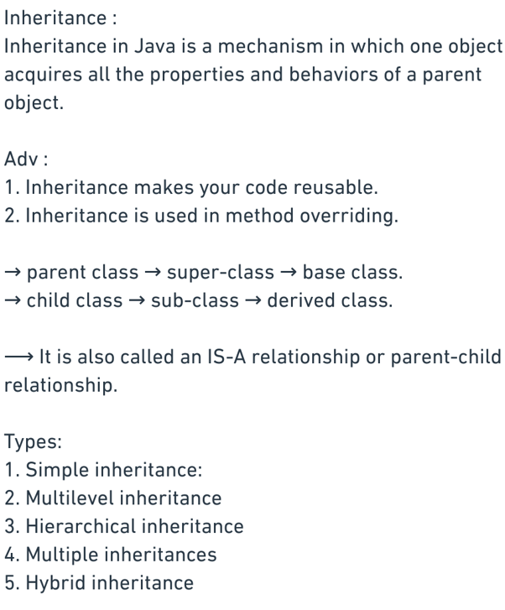

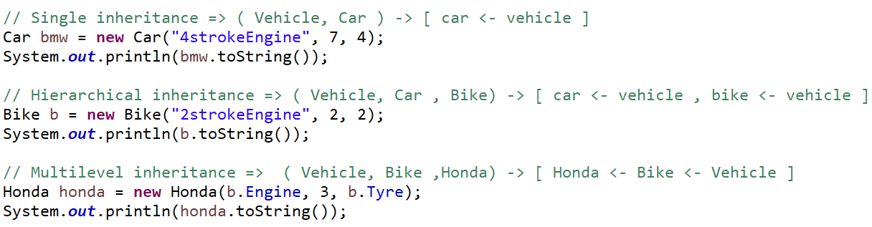

**Why multiple inheritance & hybrid not work?**

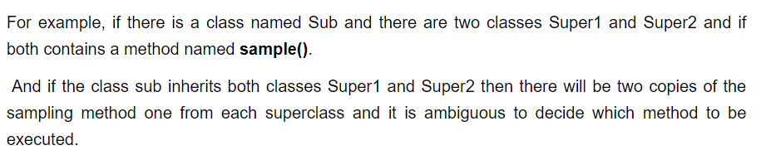

* We can achieve this by interface.

**What is abstraction and advantages?**



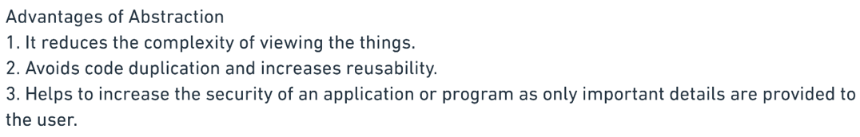

**Does abstract class has parameterize & default constructor = Yes**

**What are method we can write in abstract class = Concrete & abstract method**

**Does abstract class can create without abstract method = Yes**

**Can we create object of abstract class= No**

**Can we write method body of abstract class method= No**

**Abstract method declare inside abstract class only = yes**

**Can Abstract keyword use for variable = no**

**Can we declare abstract method as static = no**

**Can we declare abstract method as private modifier = no**



**Is abstract class pure abstraction in java? No = 0 to 100%**

**Do we need to override all abstract methods from abstract class to sub class? = yes – (not concrete method)**



**What is interface and need?** 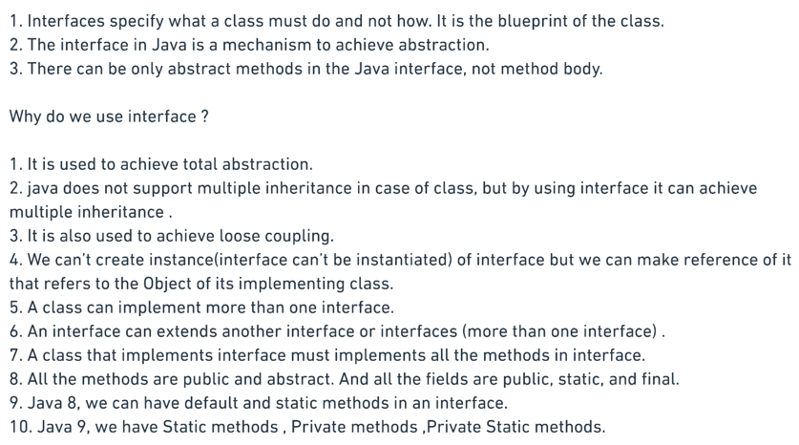

**Can we declared interface data member as private & protected modifier = no**

**Can abstract method in interface declare as final = no**

**Can we create variables in interface = yes by default static and final and we can not change value of it in subclass.**

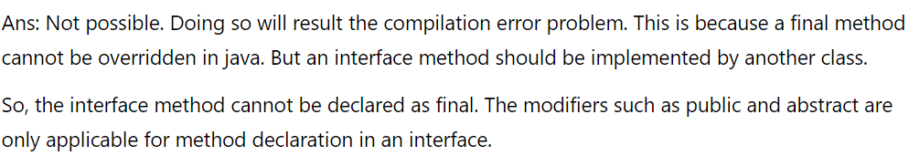

**What is differences of class & Interface**

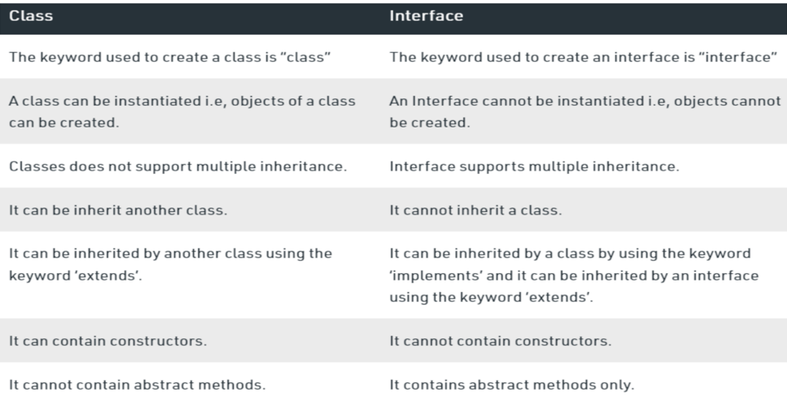

**What is marker interface?**

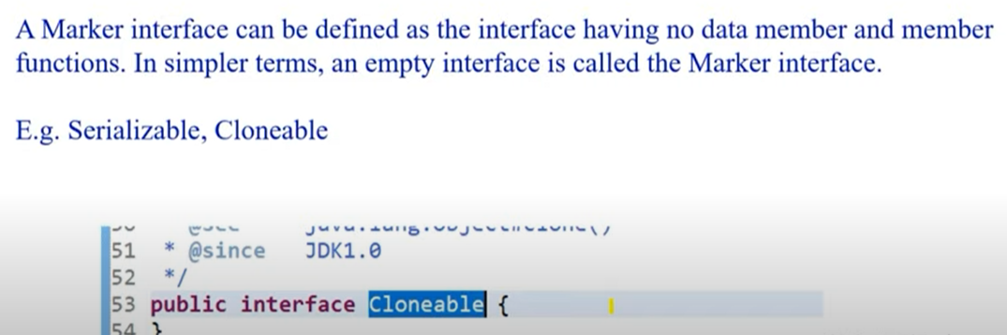

**What is differences of abstract and interface?**

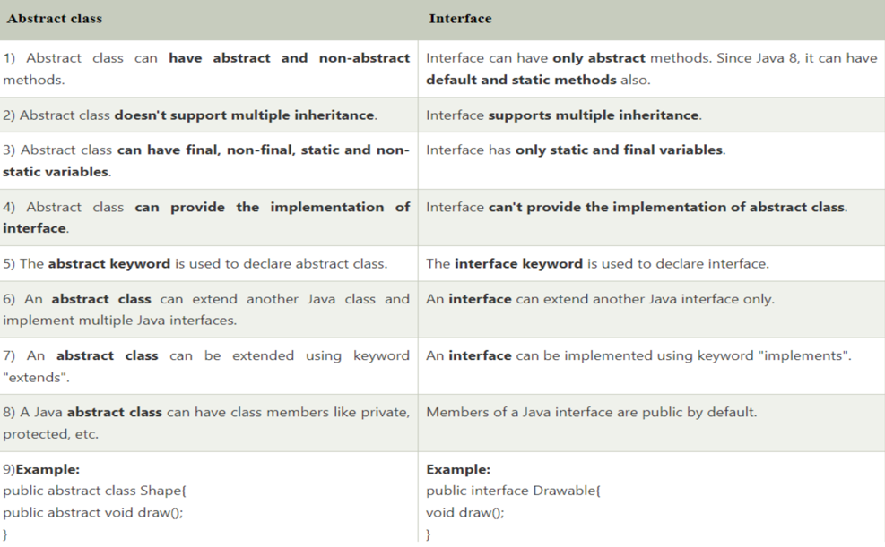

**What is polymorphism and need?**

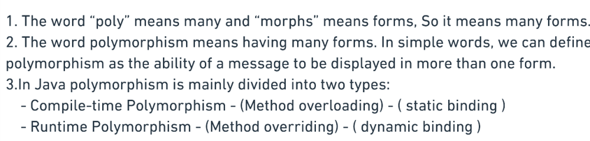

**What is method overloading?**

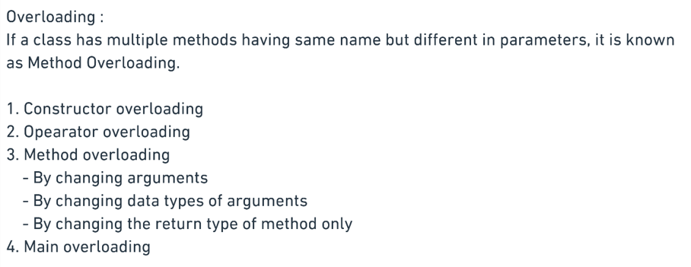

**=** if we have methods with same name and same argument but return type different = got a compile time error

**What is method over-ridding?**

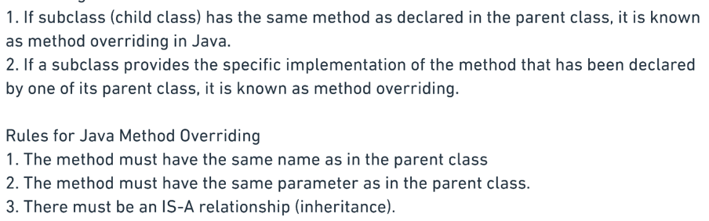

**What is differences of method – overloading & overriding?**

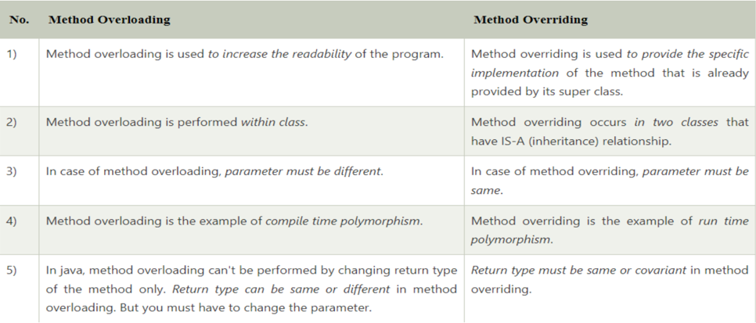

**Can we overload and override static methods?**

* If we have sub class and static method in it and parent also using same method with static we can not override it but We can overload it.

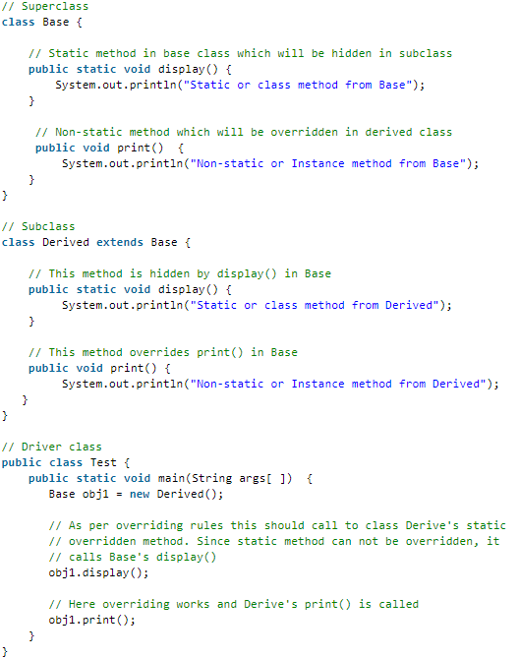

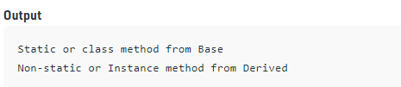

**What is differences of compile and runtime polymorphism.**

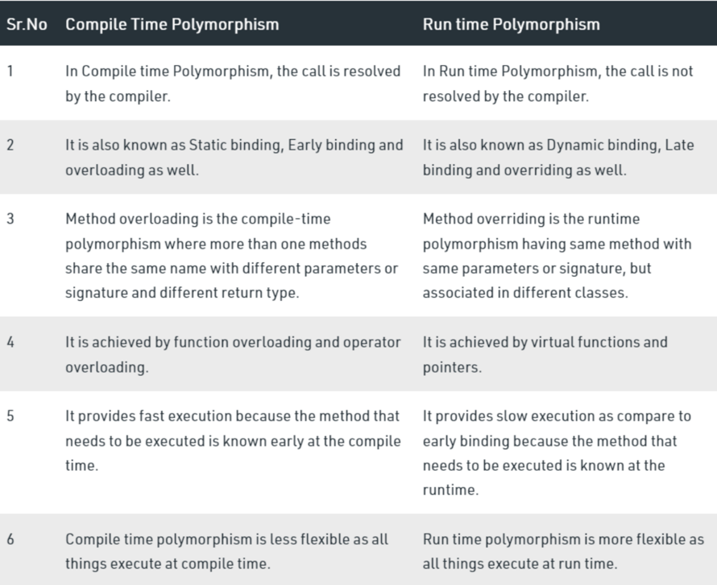

**What do you mean by packages and need?**

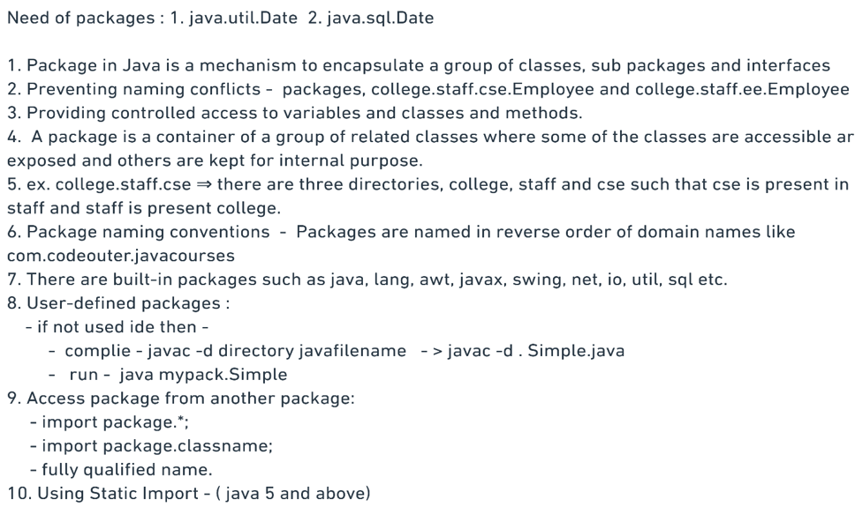

**What is access modifier & types & need?**

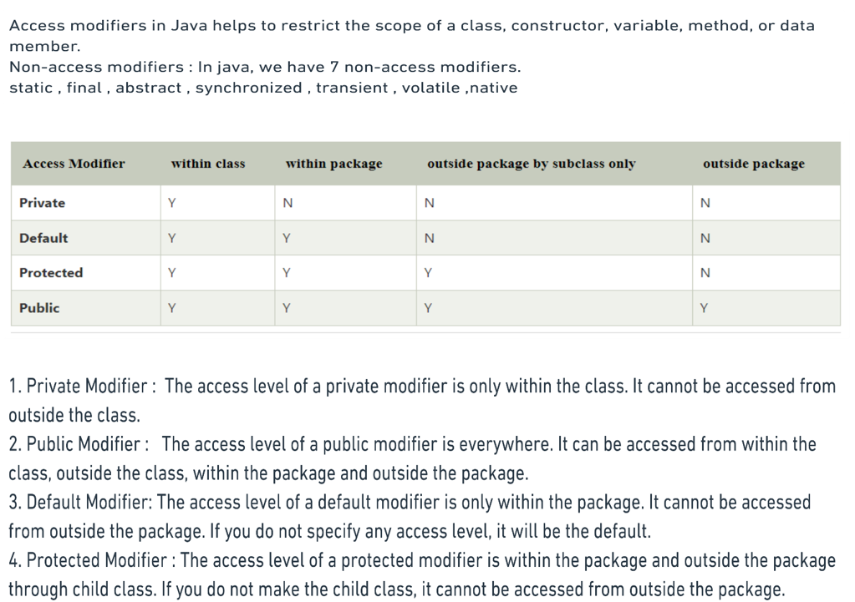

**Can class have private & protected modifier = no**

* It is by default uses public modifier

**What is Encapsulation & Advantages?**

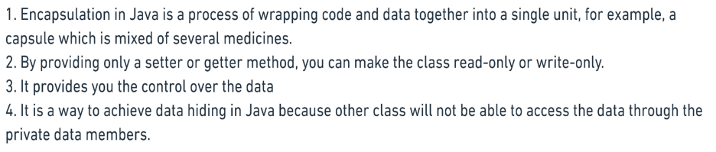

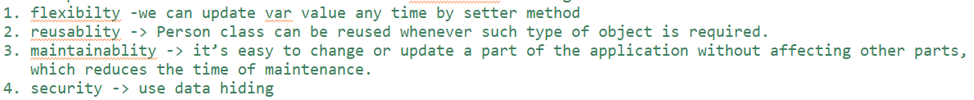

**What are differences of Encapsulation & Abstraction?**

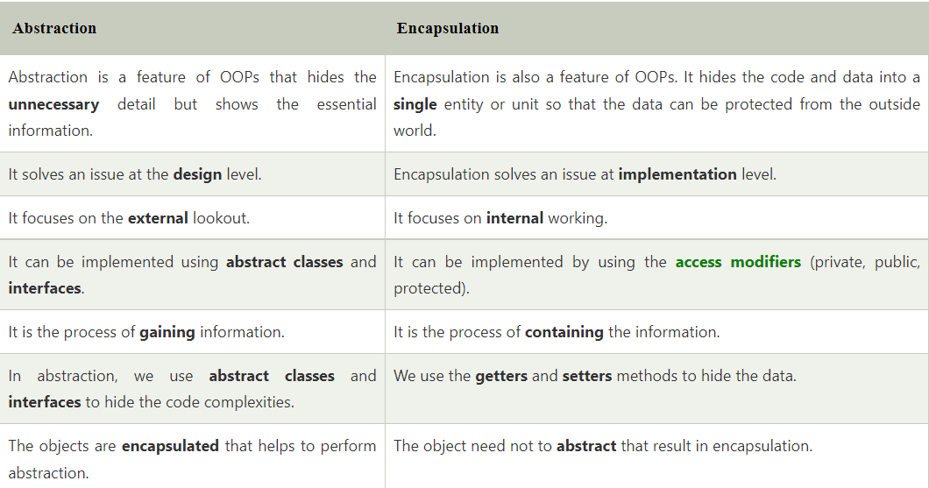

**What are inner classes and it’s type?**

* Member inner class : how to call in main method :
* 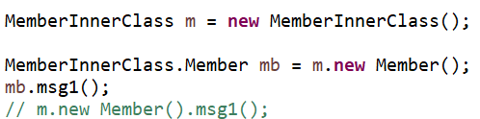
* Local inner class : how to call in main method:
* Create object of inner class in method and call it.
* Static nested class :

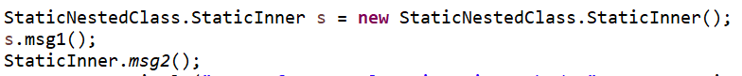

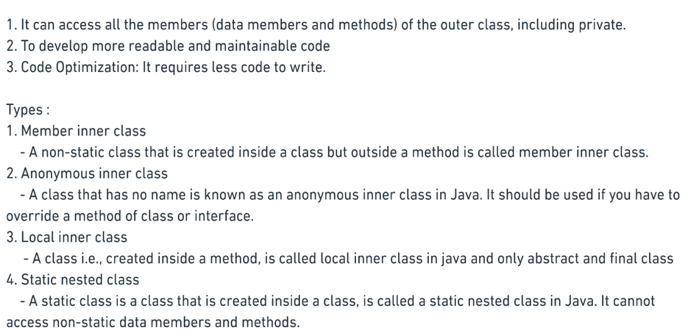

**What is nested interface?**

Class inside interface, interface inside class and interface inside interface allowed.

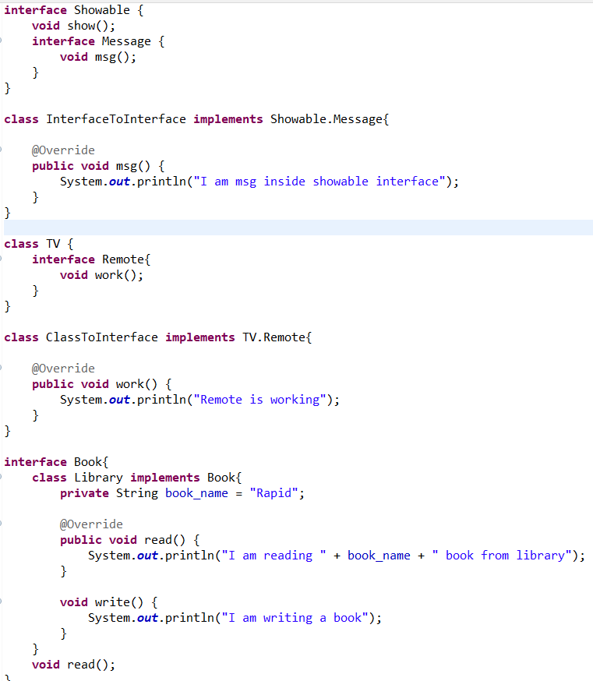

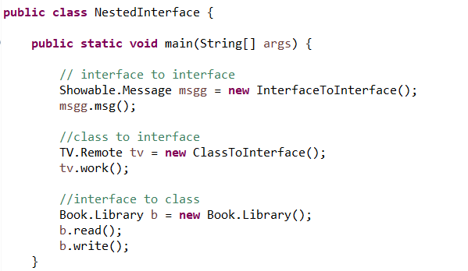

**What is Exception & types & need & hierarchy?**

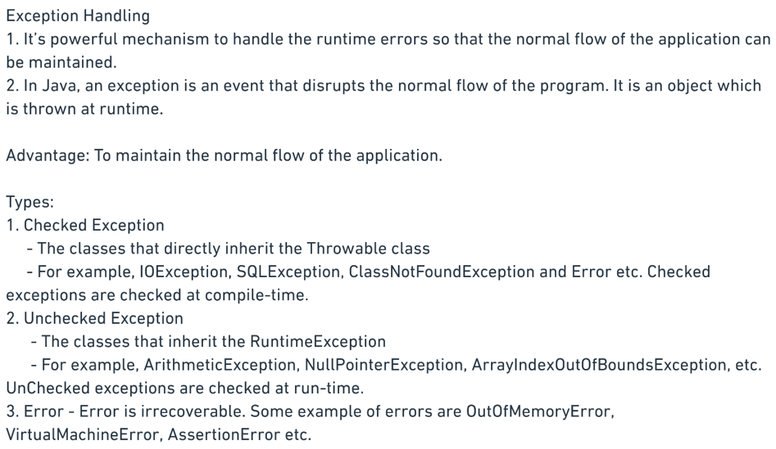

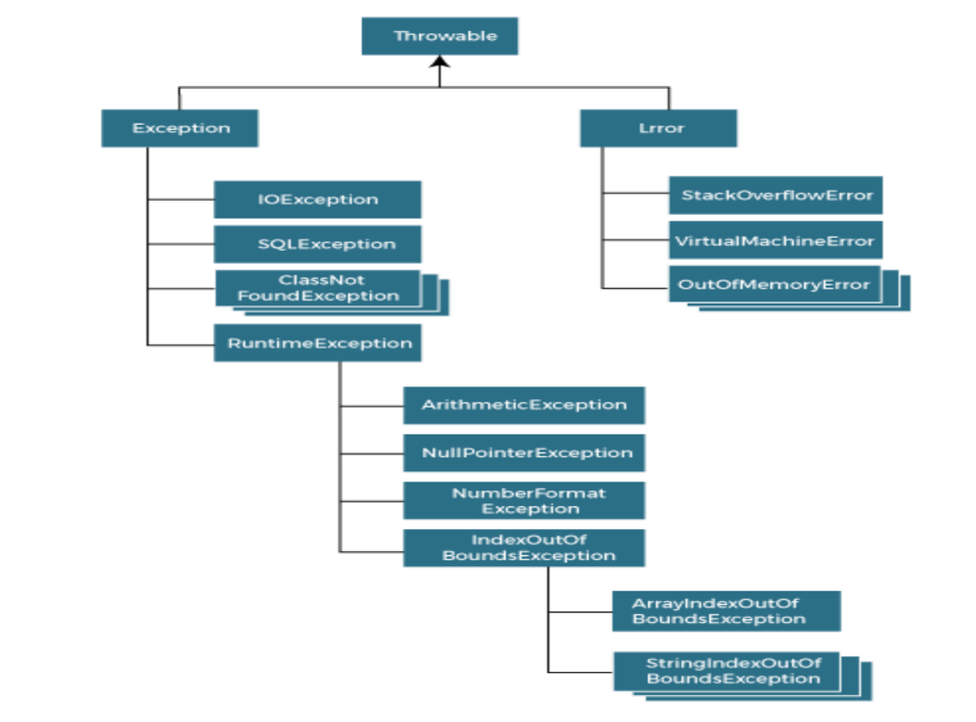

**What is differences of error & exception?**

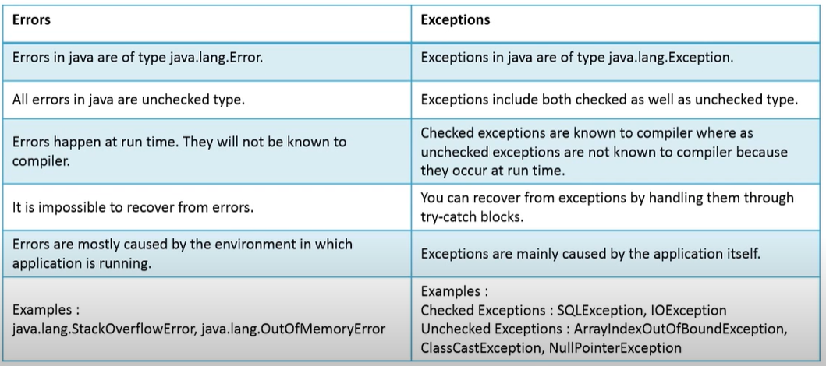

**What is try, catch, finally, throws, throw?**

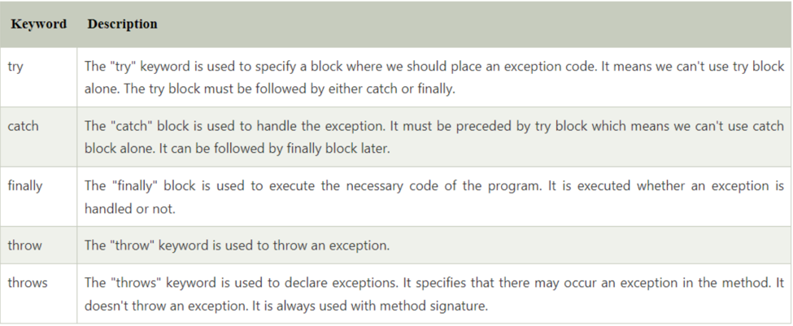

**is there multiple catch allowed and why? = yes**

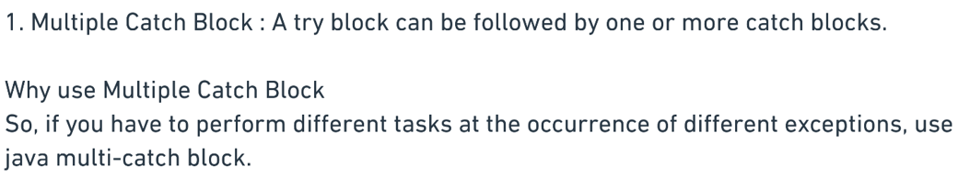

**How to nested exception?**

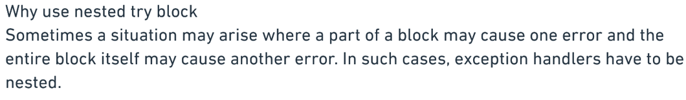

**Does finally always execute in java & uses?**

* Not in following cases : System crash and System.exit()



**What are differences of throw & throws?**

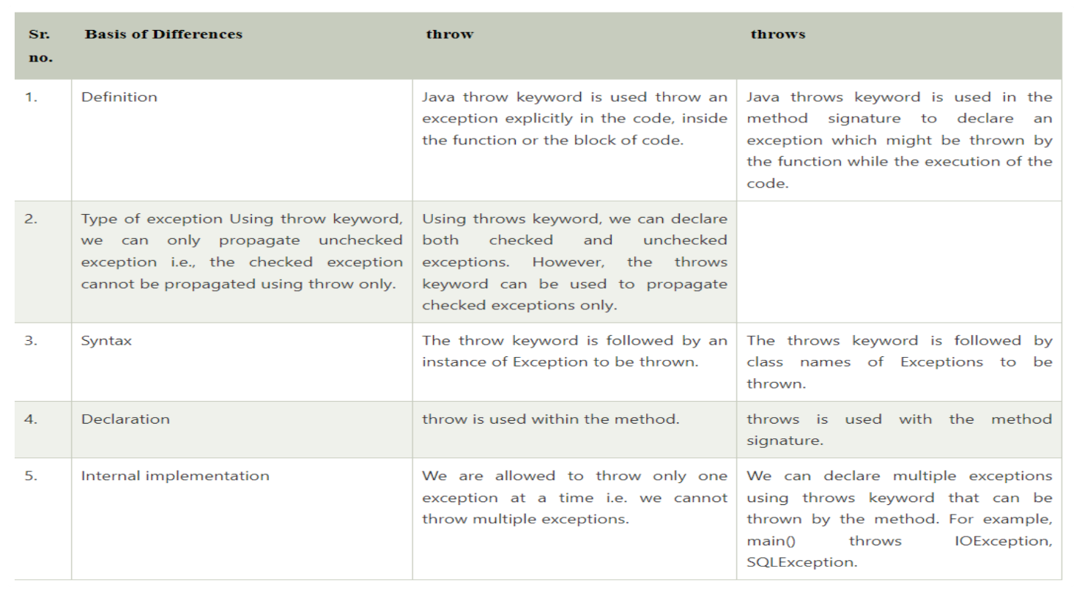

**What are differences of finally,finalize,final?**

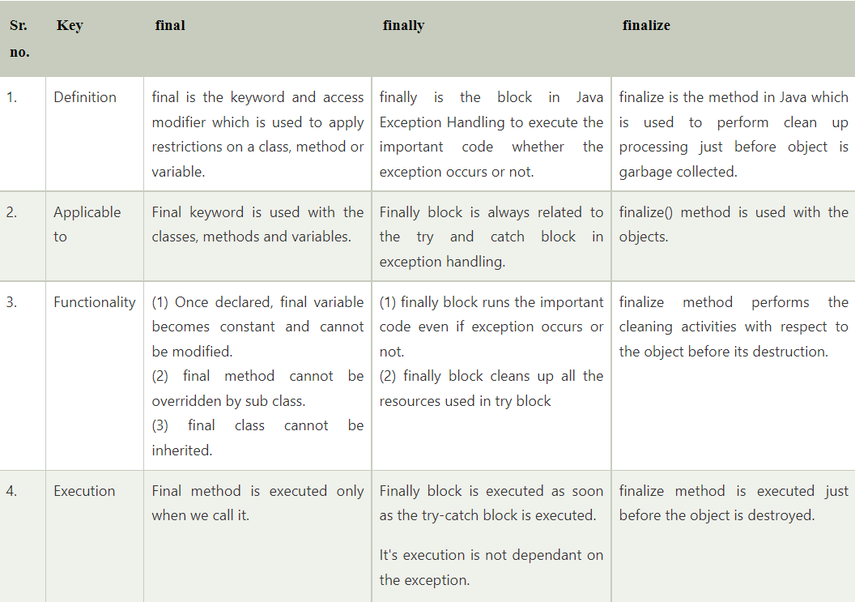

**How to create User define exception?**

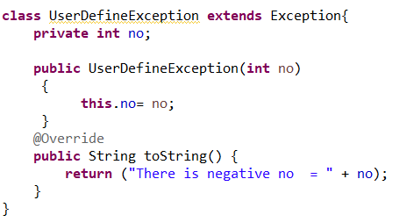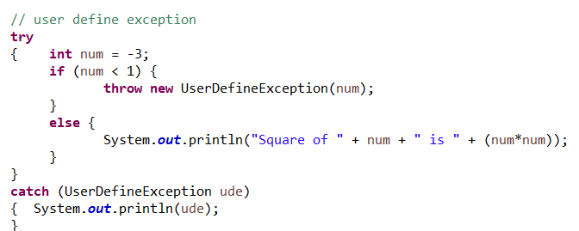

**What is advantages or disadvantages of File ?**

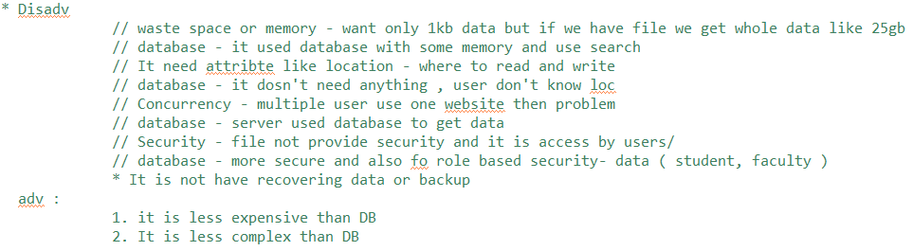

**What is serialization & deserialization & transient keyword?**

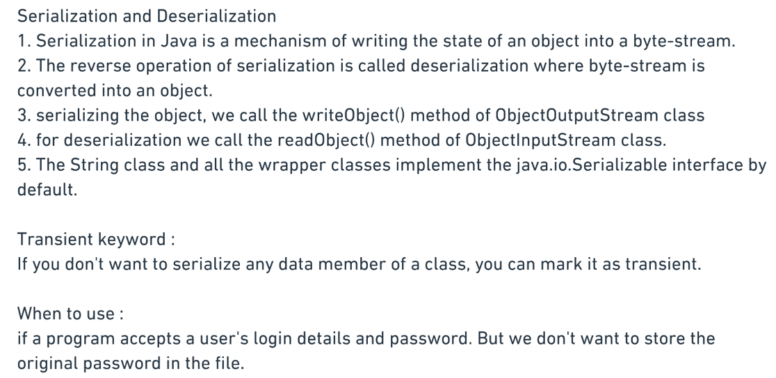

**What is Serial Version UID?**

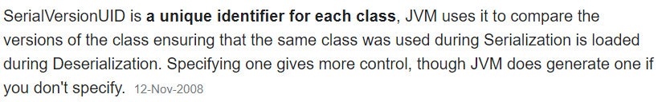

**What are all methods present in object class?**

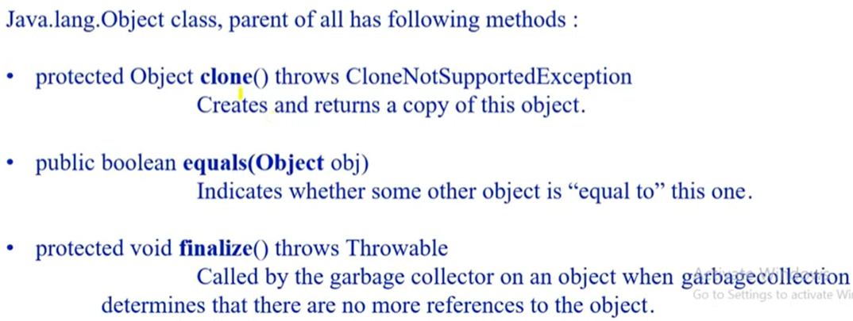

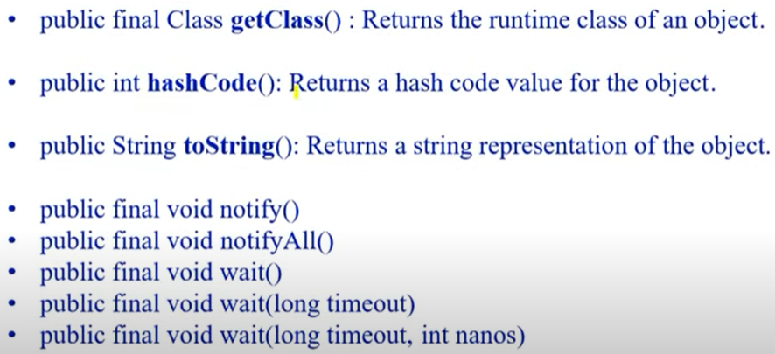

**How can you make class is immutable?**

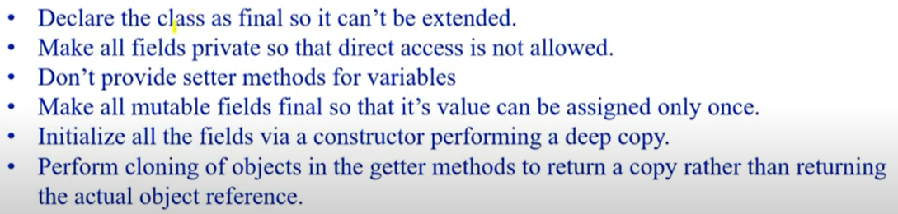

**What are differences of process and thread?**

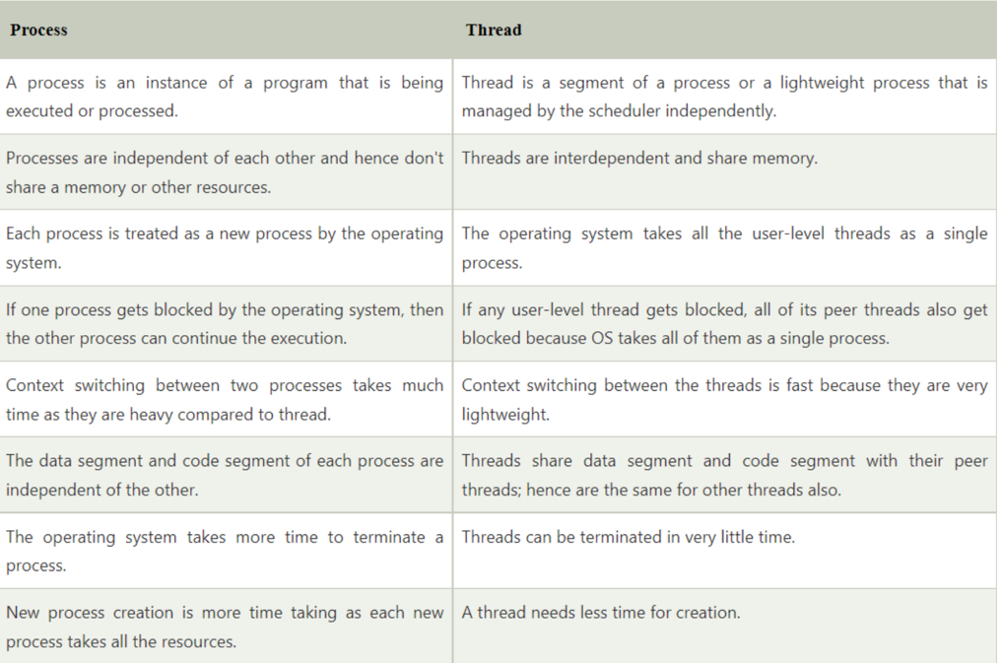

**What Is lifecycle of thread?**

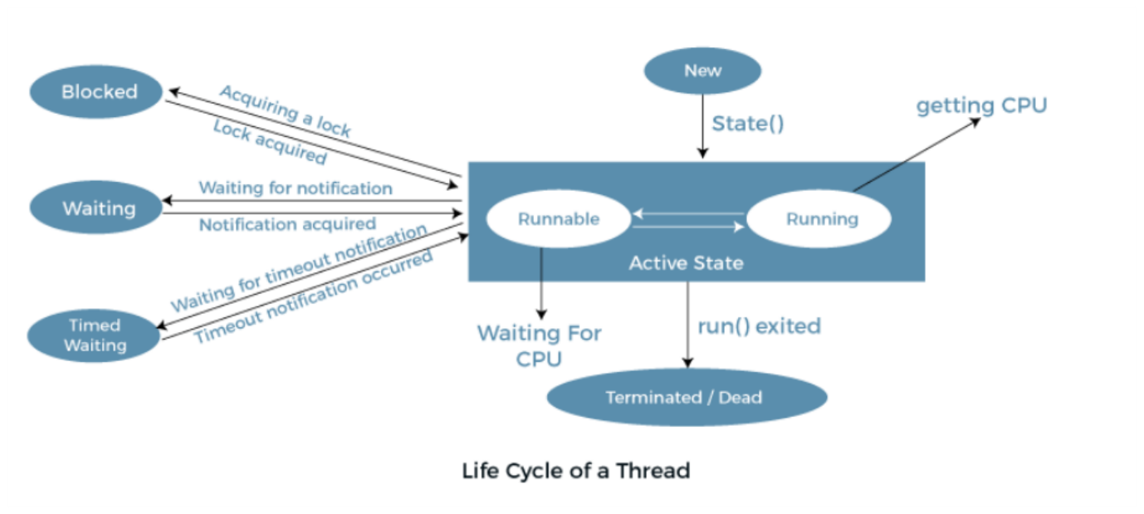

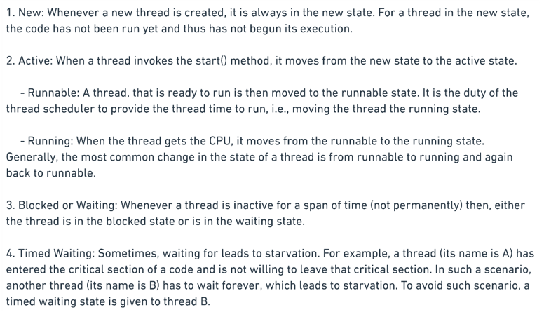

**What are ways to create thread?**



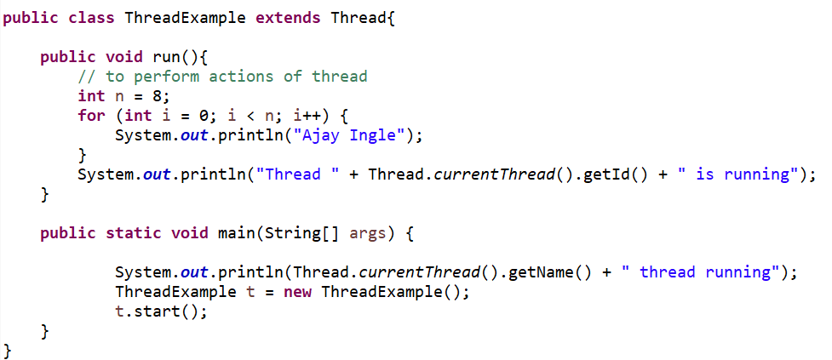 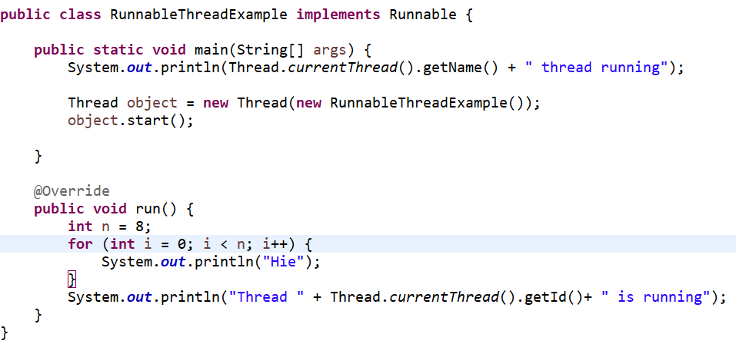

**What all methods in thread?**

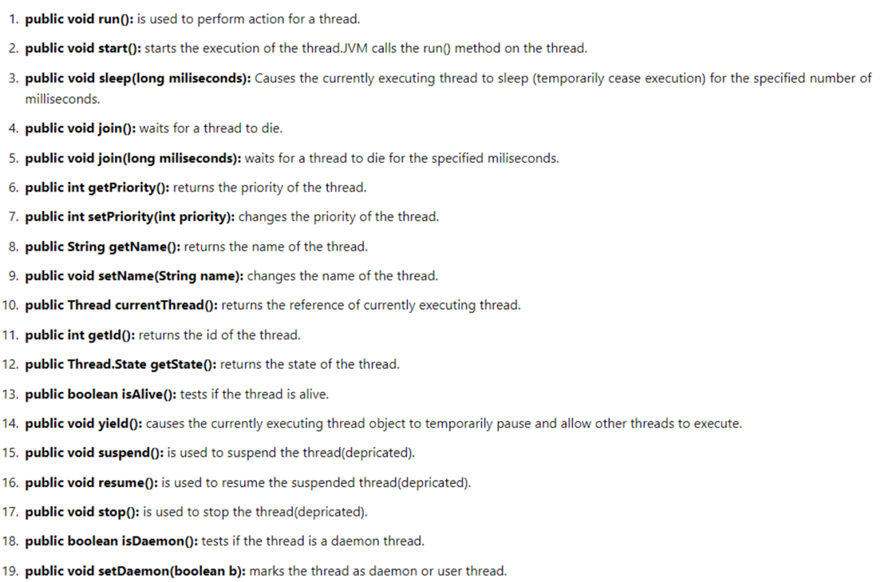

**What is Daemon thread?**

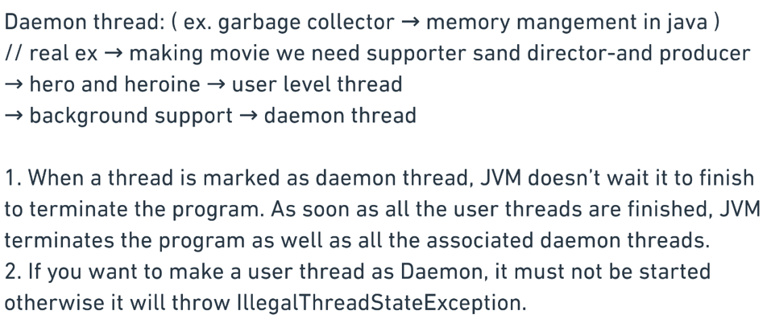

**What is concept of synchronization?**

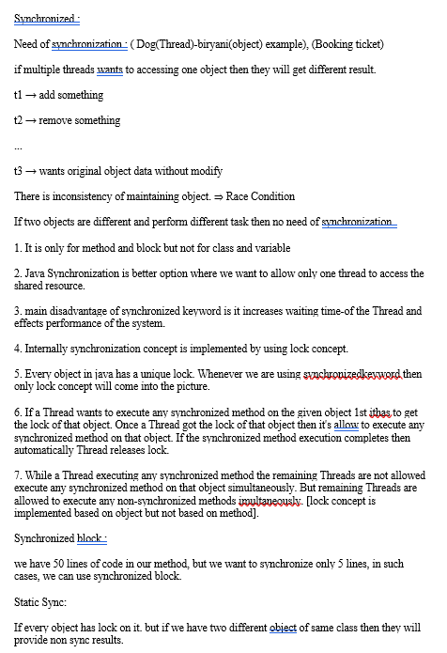

**How Intercommunication works in thread?**

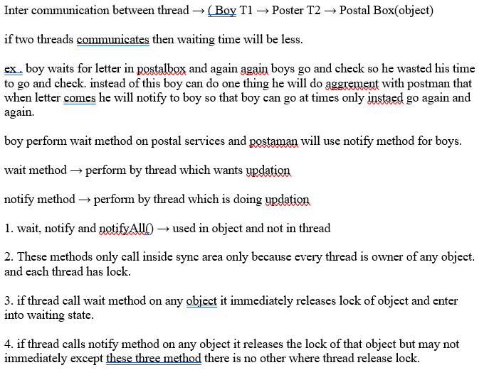

**Differences of wait() and sleep()**

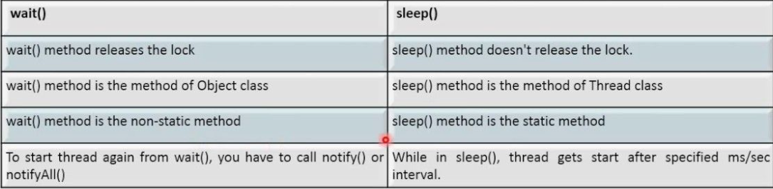

**Differences of notify() and notifyAll()**

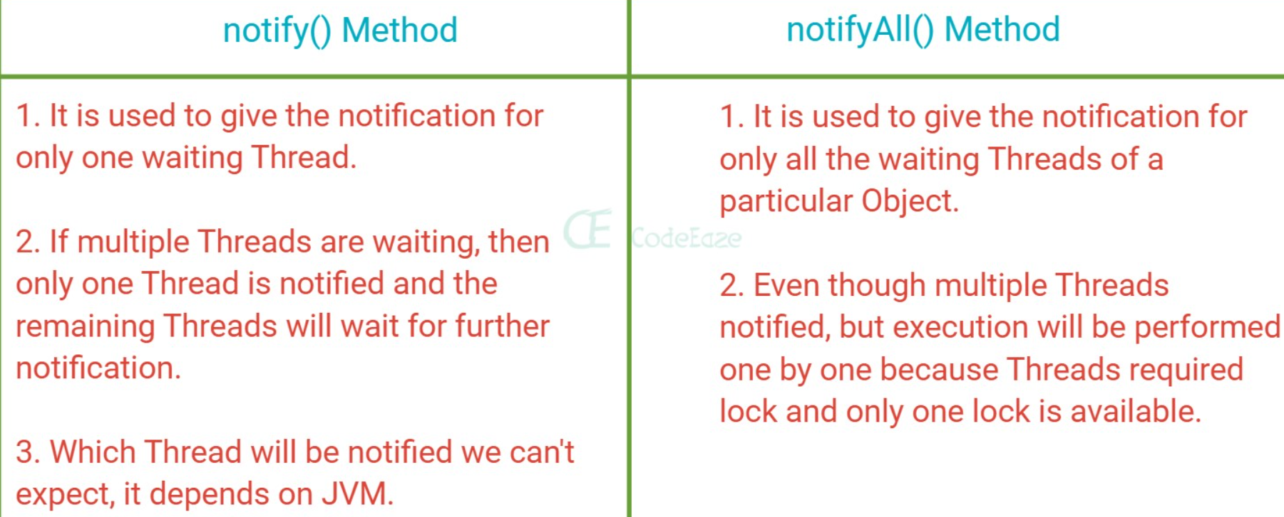

**What is singleton class and how to implement it?**

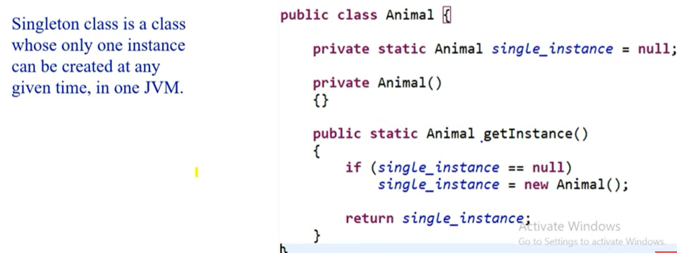

**Why java 8 and main reason?**

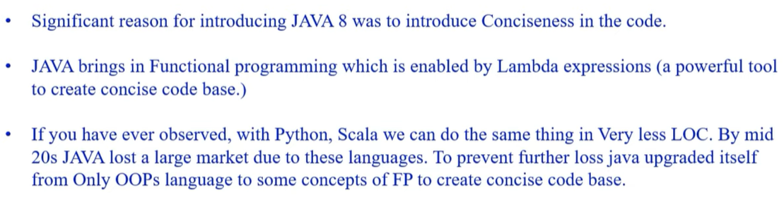

**What are all java8 features?**

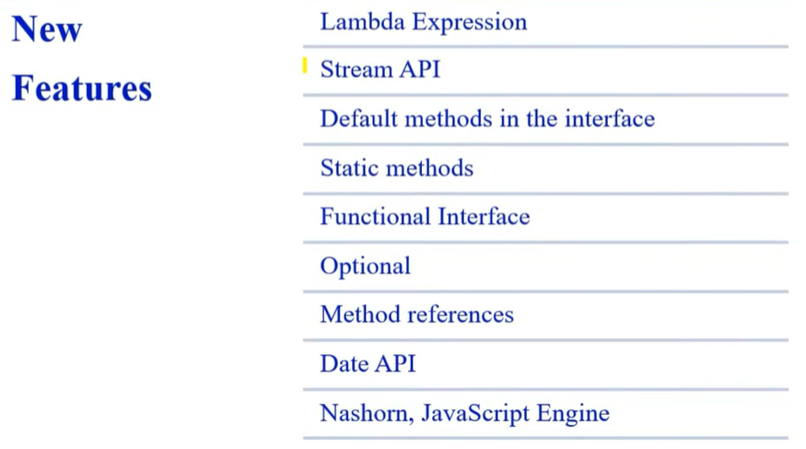

**Advantages of java8**

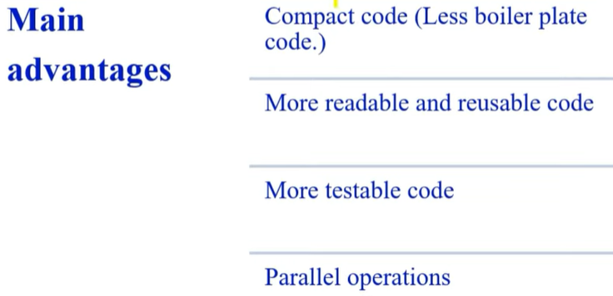

**What is Lambda expression ?**

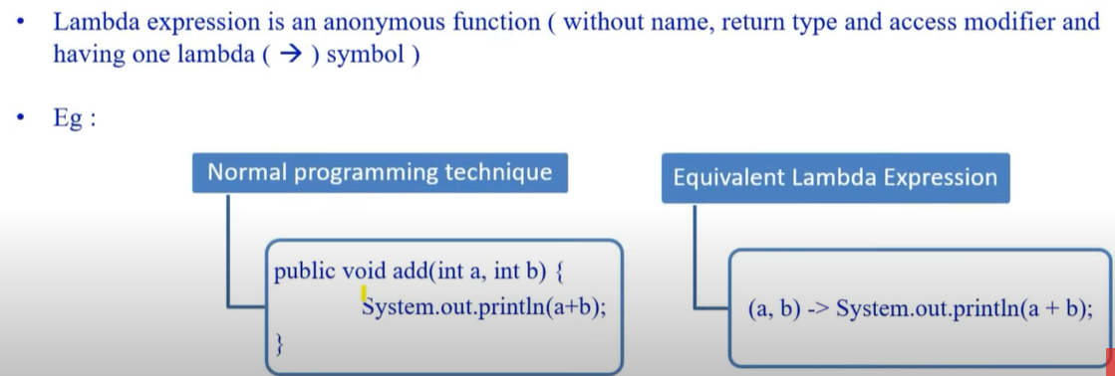

**What does mean functional interface?**

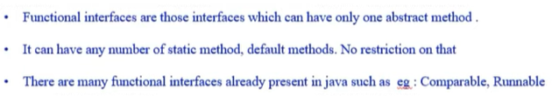

**How lambda & functional interface work togther?**

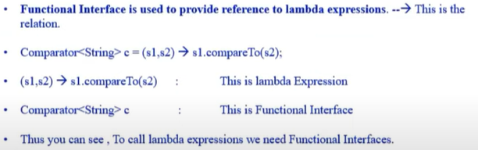

**Can we create own functional ineterface?**

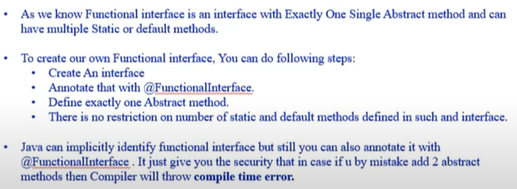

**Why and what is method reference ?**

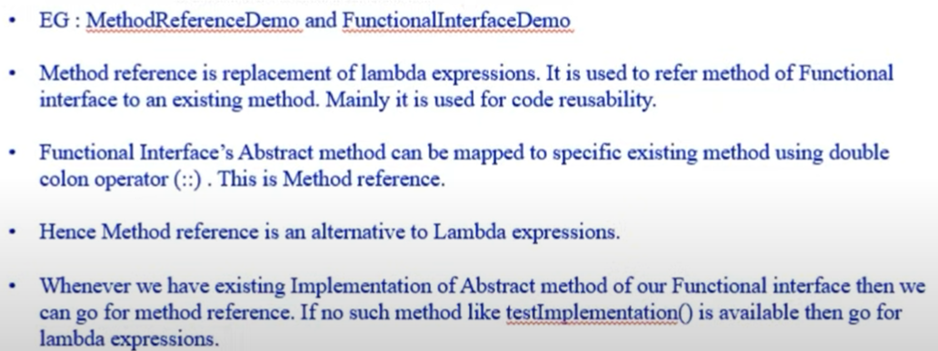

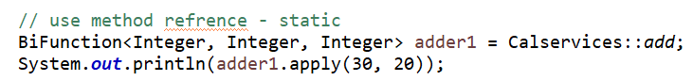 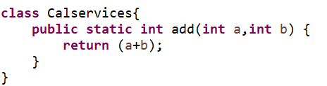 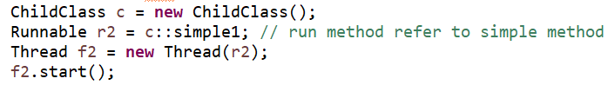

**What is default method?**

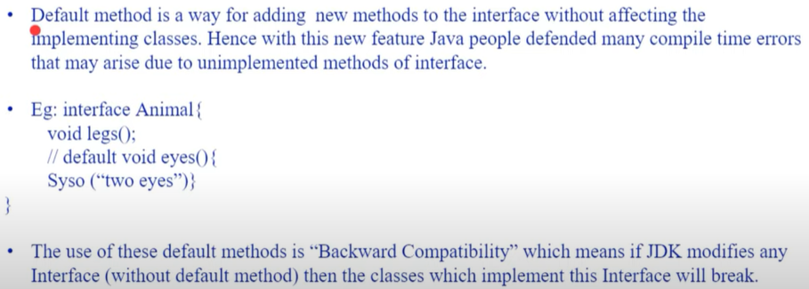

**Is it necessary to override default method? - No**



**Is default method access modifier?**

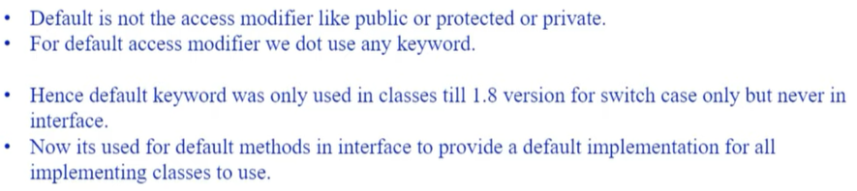

**Can we override methods of object class as default method?**

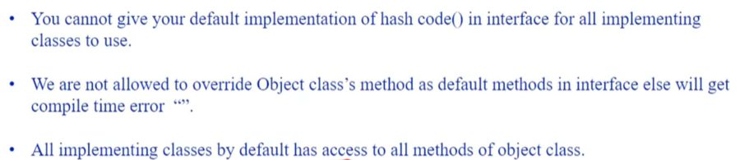

**Why static method is introduced in java 8?**

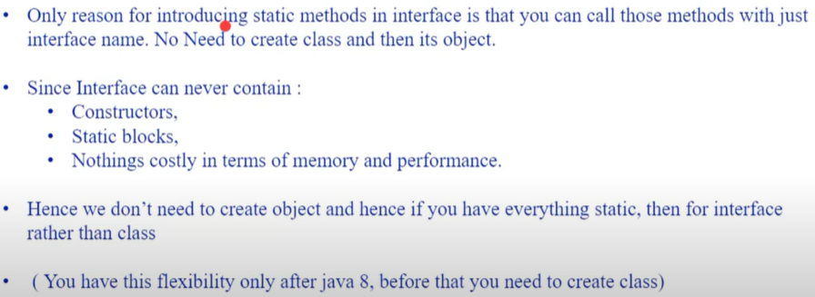

**What is Predicate?**

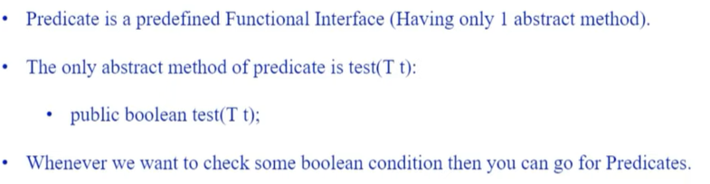

Ex. Predicate<Integer> g = p -> p%2==0; - Sysout(g.test(20)) = true

**How to use predicate for joining? => and(), or(), negate()**

**What are Functions?**

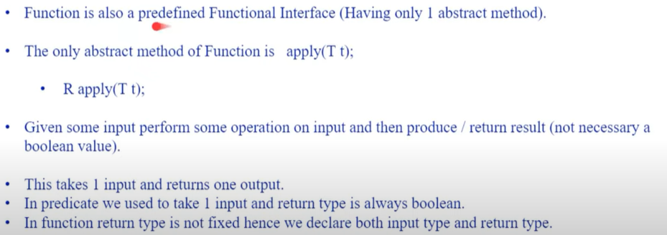

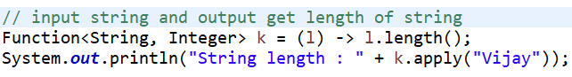

**Differences of predicate and Function?**

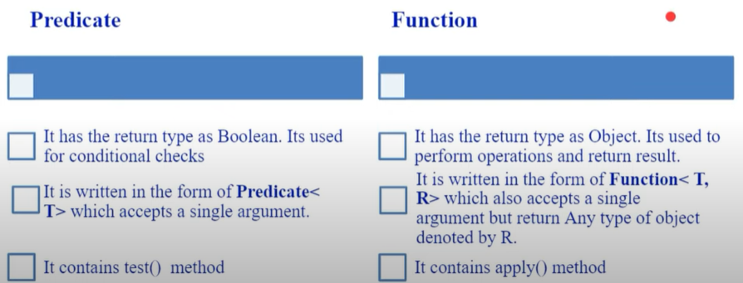

**What is functional Chaining?**

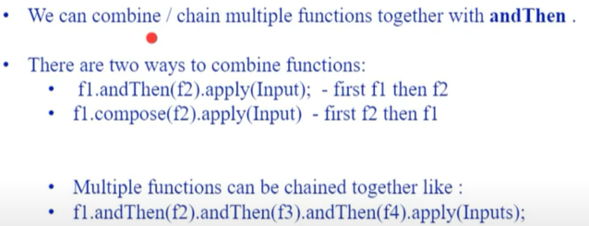

**Ex. Output : 64, 16,16,64**

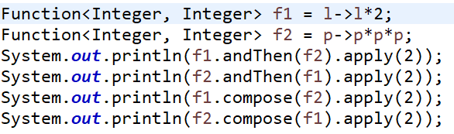

**How consumer works?**

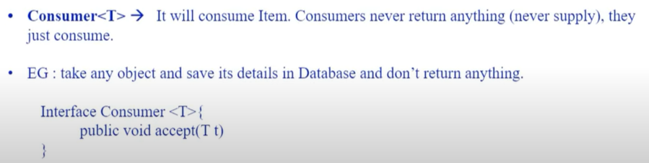

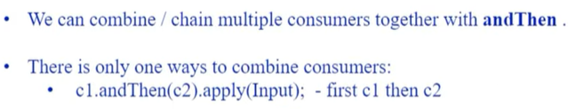

**Ex. Output : c1: 6 , c2:27 and c2:8 , c1:4**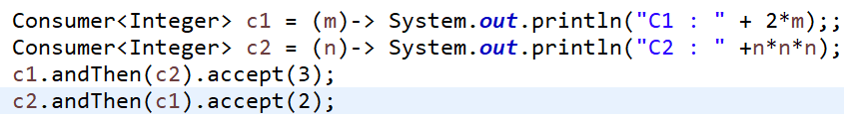

**How Supplier works?**

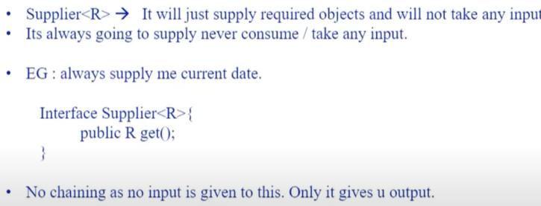

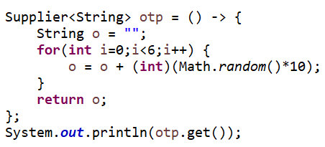

**BiConsumer, BiPredicate,BiFunction but Not BiSupplier?**

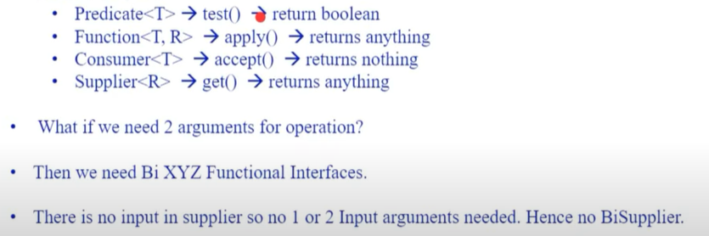

**Ex. True, false , 50.**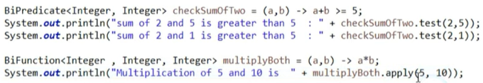

**Is there any way to take more than 2 arguments?**

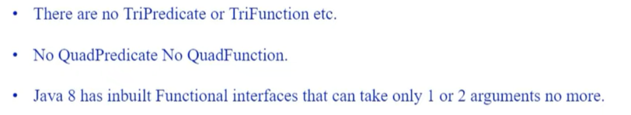

**What is Streams?**

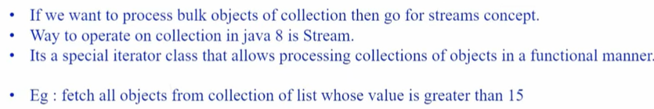

**Differences between java.io.stream and stream api in java8?**

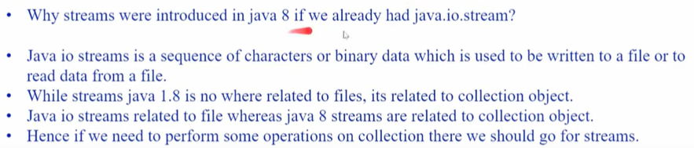

**Differences of collection & stream**

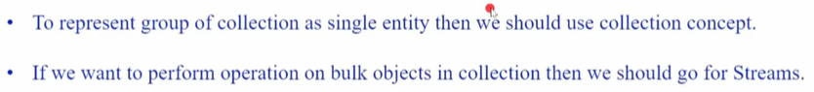

**How to filter stream object?** = filter objects



**What is map and how to write in stream?**

Map – used to do operations on collection of objects



**How sorted works in stream and how to use customize sorting?**

**Approach 1 :** want ascending order = Collections.sort(a);

Want descending order = implement class as Comparator and override method compare and return object2.compareto(object1)

**=** Collections.sort(a,new classname())

**Approach 2 : use lambda**

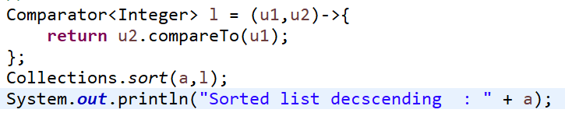

**Approach 3 : use stream()**

**Ascending :**



**Descending :**



**How to use max and min in stream?**

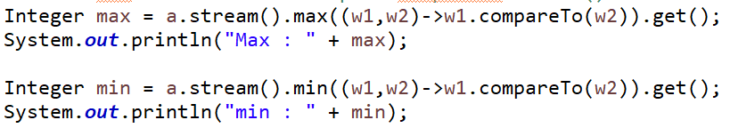

**How to use ForEach in stream?**

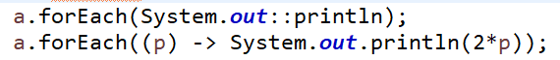

**How to use toArray() and of() in stream?**

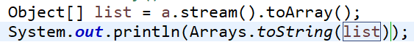

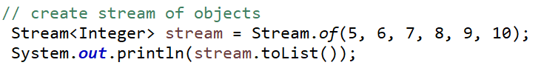

**What is Optional class and how to use it?**

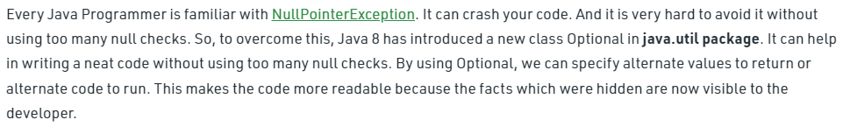

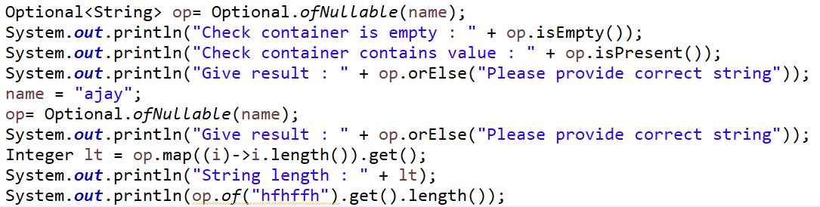

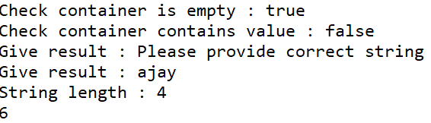

**How to use constructor reference in java8?**

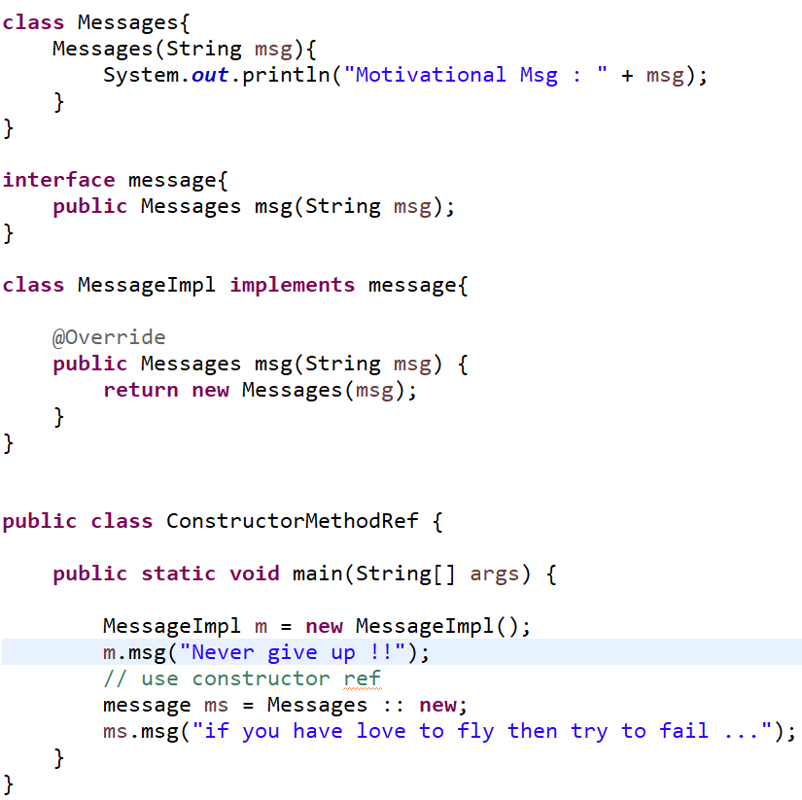

In above approach don’t use inheritance concept if u know constructor reference = classname :: new

**How to use base64 URL and MIME encoder & decoder?**

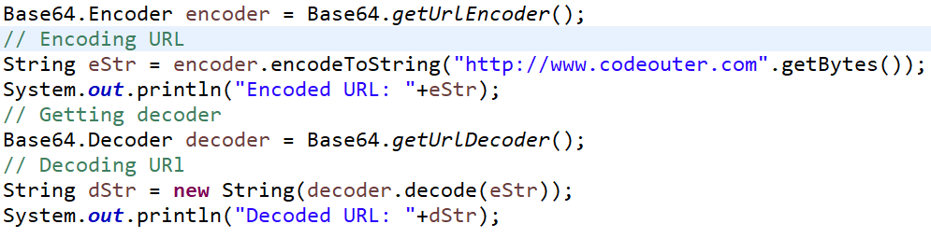

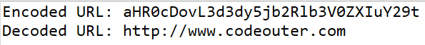

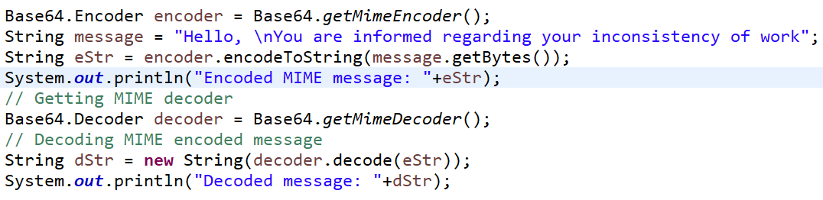

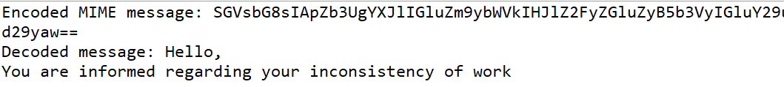

**Differences of map and flat Map?**

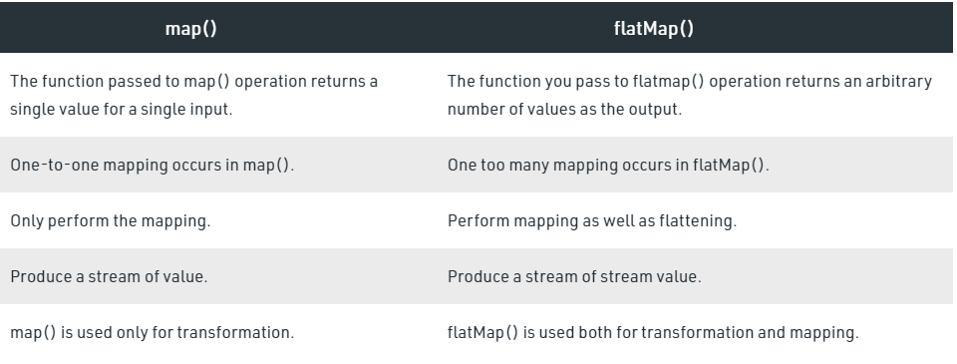

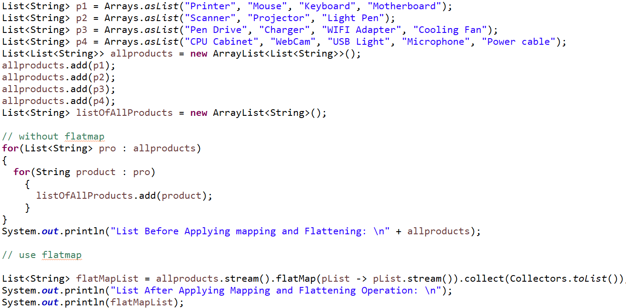



**What is new in date /time API in java 8?**

**What differences of list and Set?**

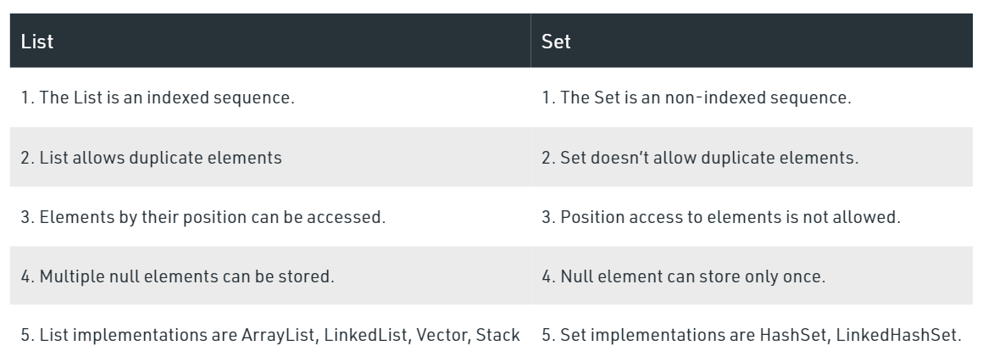

**What is differences of Array List and Linked List**

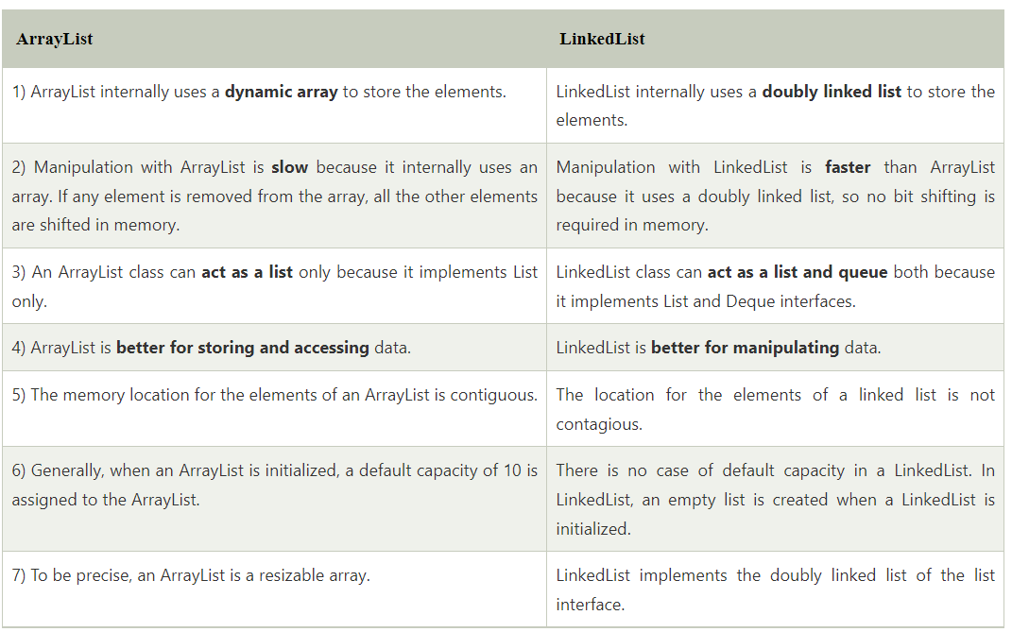

**Can we use final to Arraylist object?**

* Yes we can use but we can’t assign new Arraylist to old arraylist object. But we can modify elements present in arraylist
* 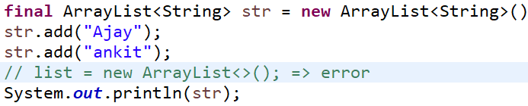

**Can we create customize arraylist where it not contain any duplicate element? = Ans [ 1, 2]**

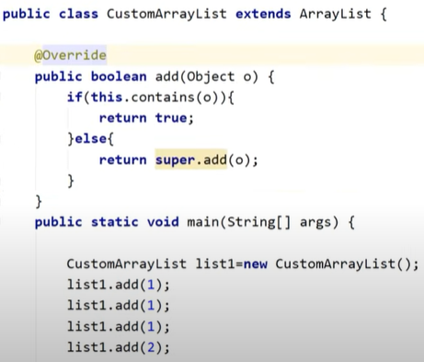

**Why Set doesn’t allow duplicate element?**

* Because internally set uses map to add elements as argument it take keys we know map contains every key unique

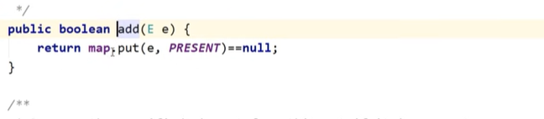

**Is Set given always unique result?**

* Not in following case :
* When you create your custom class and pass to Set
* 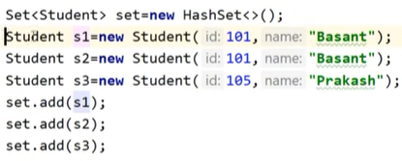
* Student class should override equals and hashcode method for unique

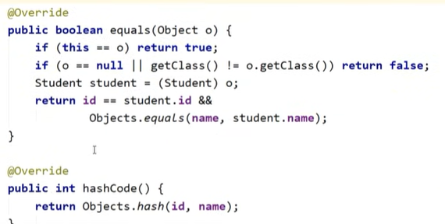

**Differences of comparable and Comparator?**

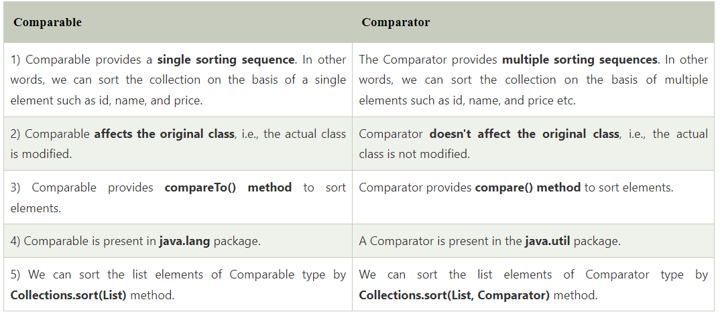

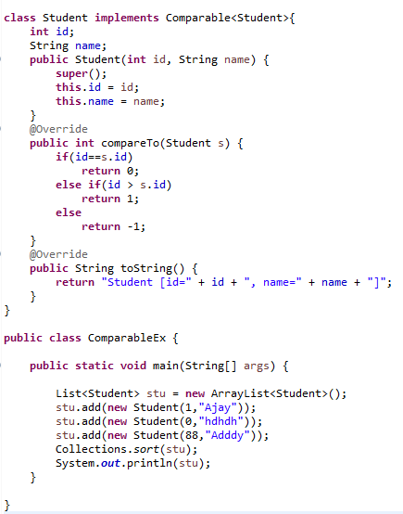

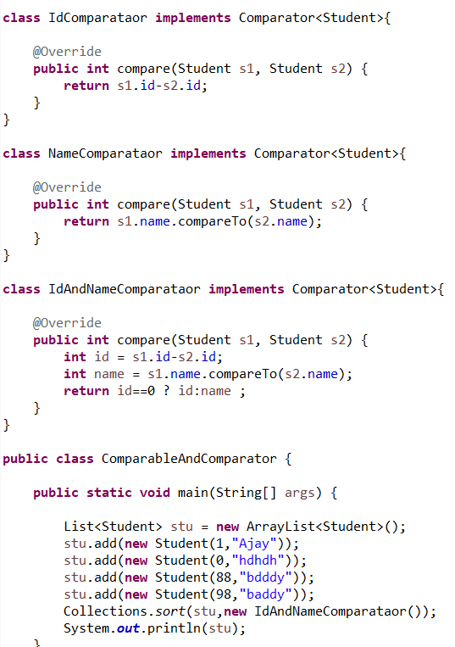

**What are differences between fail fast and fail safe iterator?**

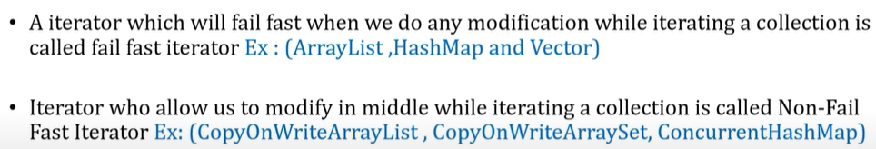

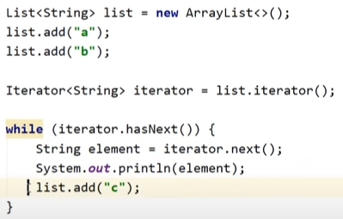 **Exception come**

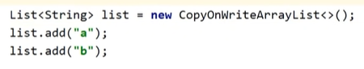**Exception remove**

Your element is not added to list in result

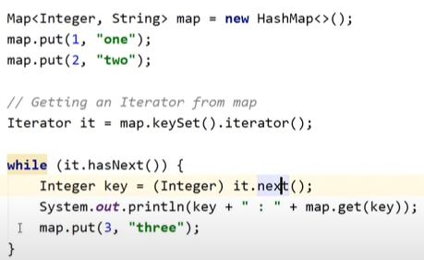 **Exception come**

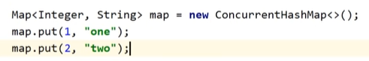 **Exception remove**

Your element is added to map in result

**What is difference of hashMap & concurrent HashMap**

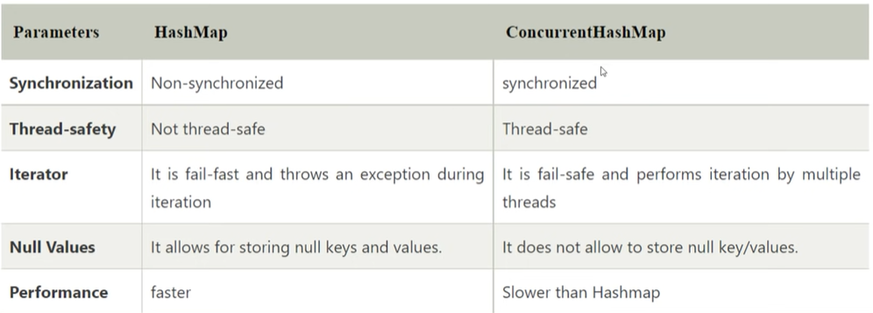

**If we have hashtable as synchronized already then why we need to use concurrent hash map?**

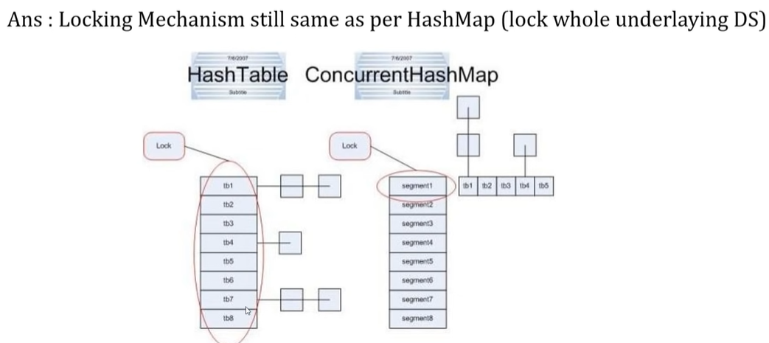

Hashtable uses locking system internally on all element once but in concurrent hash map it apply lock on single bucket at time.

**We can use synchronize a hashmap using collection instead of using concurrent hash map?**



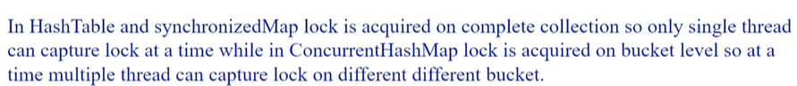

**How HashMap internally works?**

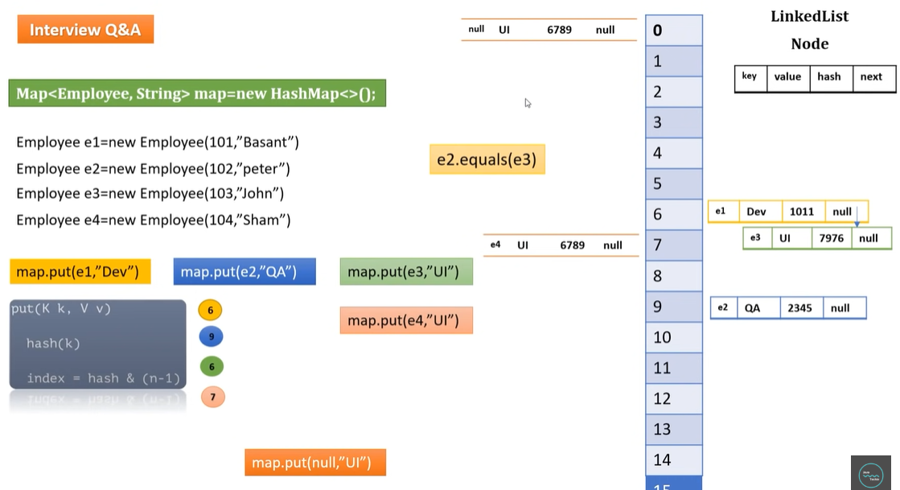

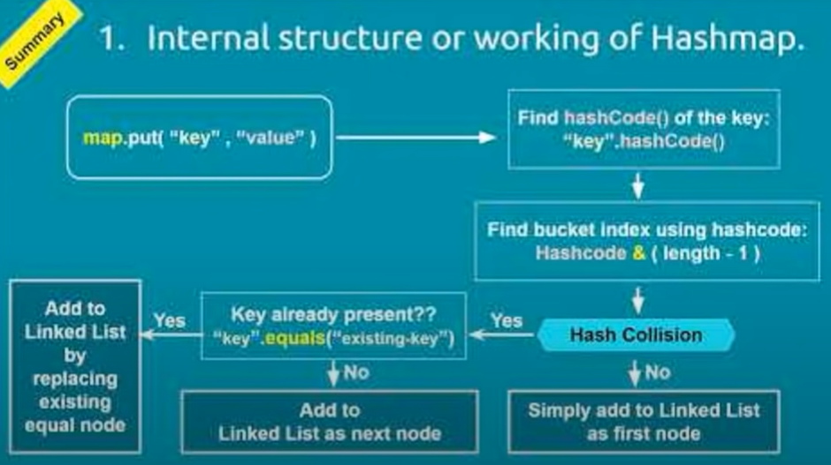

In java 8 they use balanced tree concept instead of Linked Hash Map

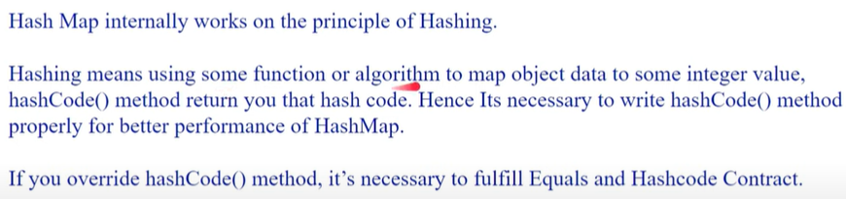

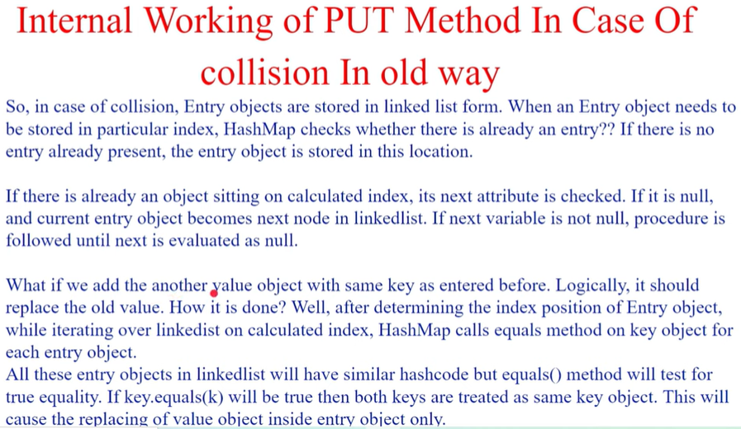

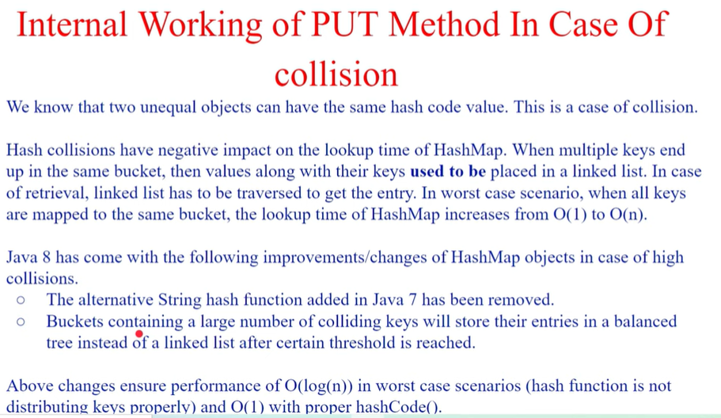

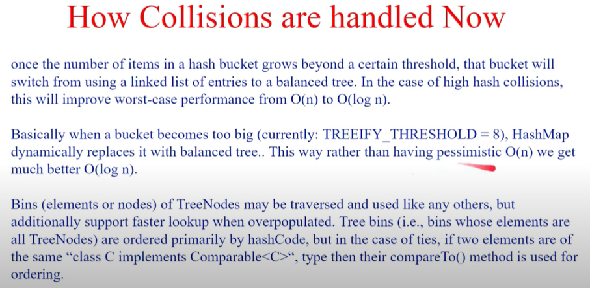

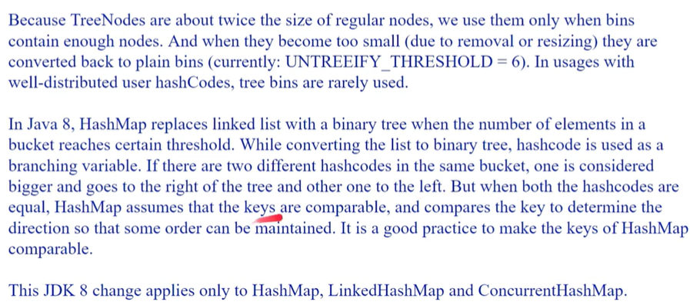

**Why we need Concurrent Collection?**

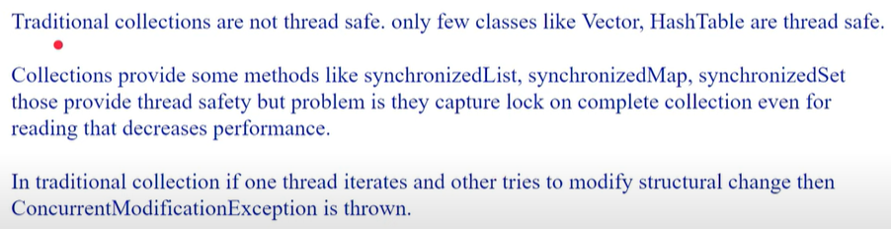**What is concurrency level of concurrent hashMap?**

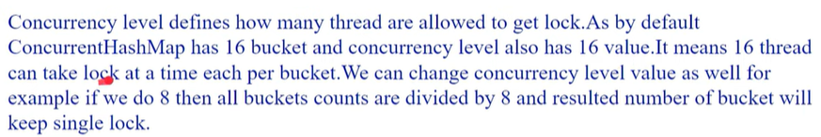

Ex. We have 16 buckets so bucket size = 16 and so in each segment 2 bucket will there so lock apply on 2 buckets at time.

**Can thread read & write from concurrent hashMap simultaneously?**

* Thread can read but not write, every thread need locks on write

**Difference of ArrayList and Vector**

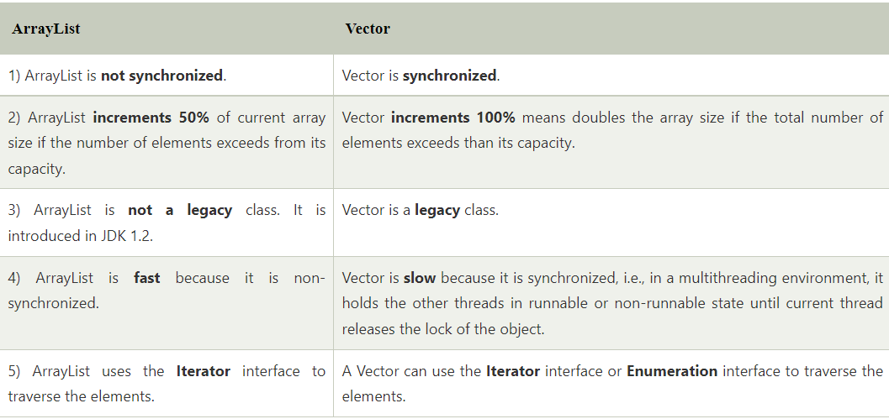

**Advantages of ArrayList over arrays.**

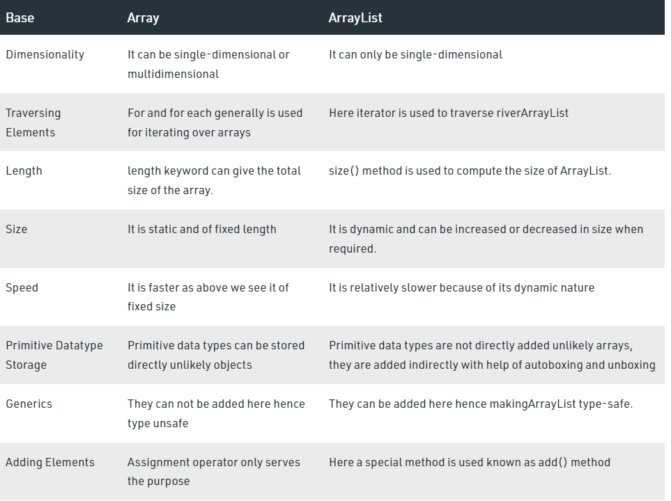

**What is Collection & Advantages and what is need?**

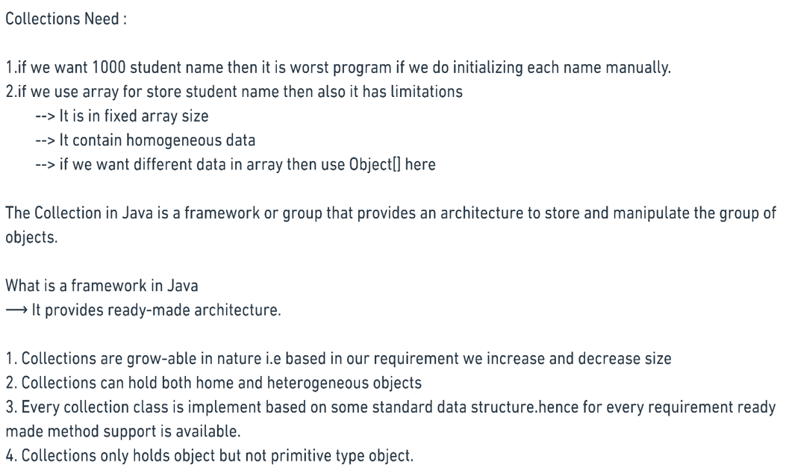

**What is differences of Collection and Collections.**

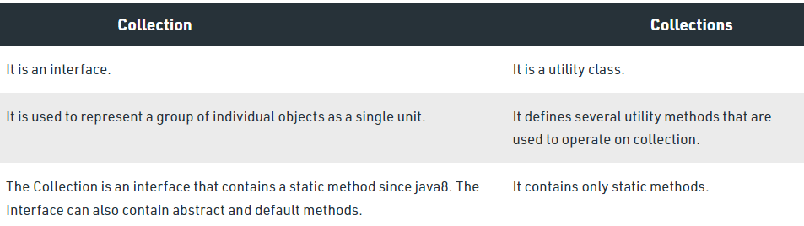

**What is hierarchy of Collection?**

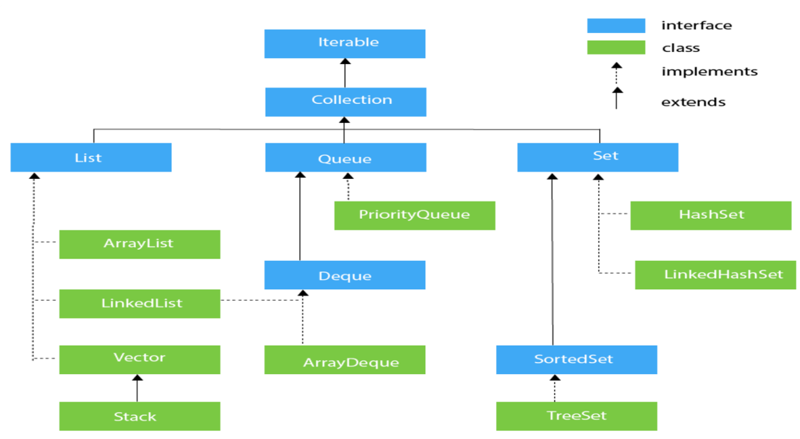

**What is Stack in List Interface?**

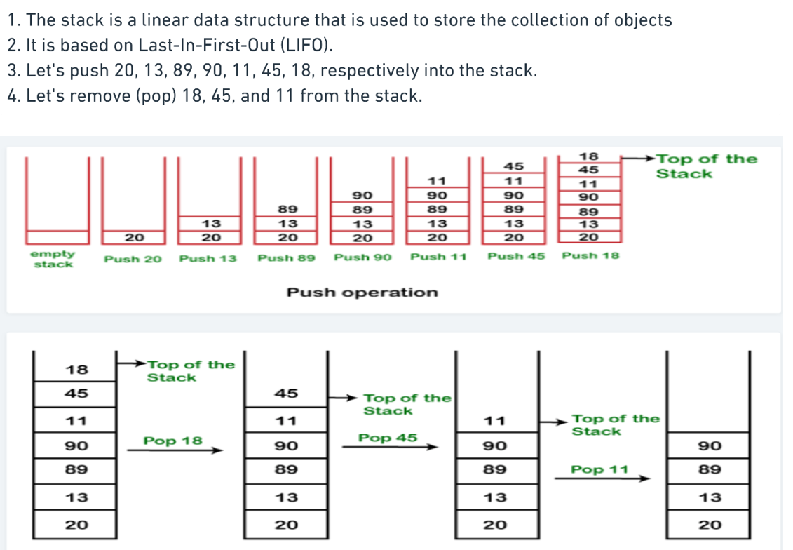

**List of Cursors in collection**

1. Enumeration – only used to read data

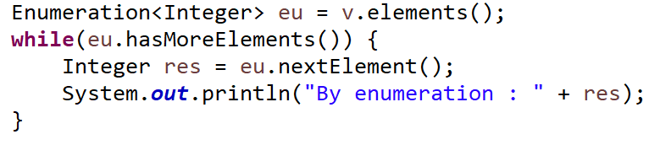

2. Iterator – used to read and remove data while iterating

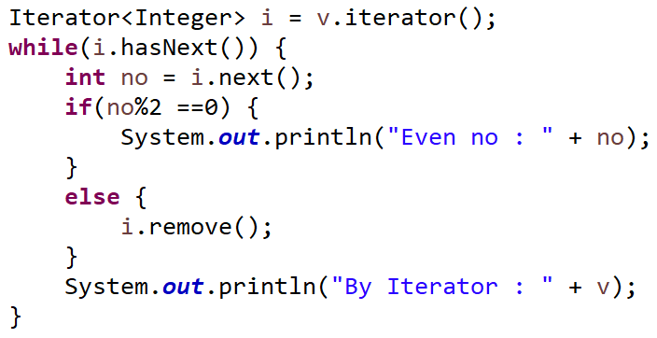

3. List iterator – used read, add, set, remove data while iterating

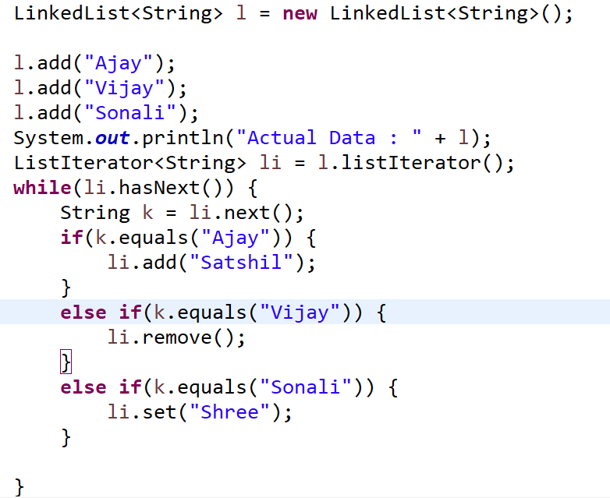

**How HashSet works internally?**

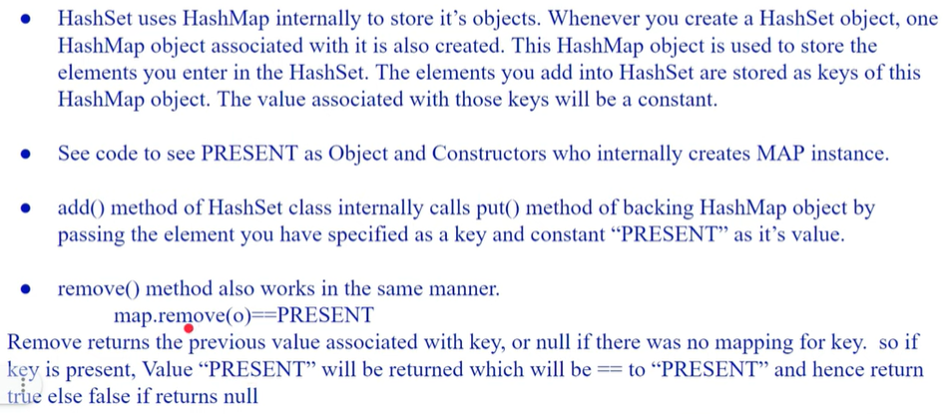

**Diff of HashSet and LinkedHashSet**

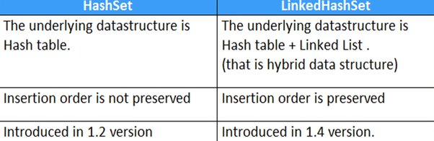

**-** no null value for both

**How TreeSet works internally?**

Treeset uses TreeMap internally and rest of things similar as hash set imple..

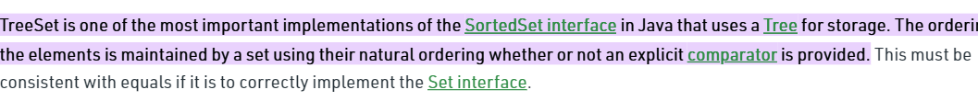

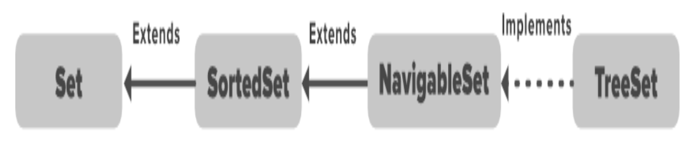

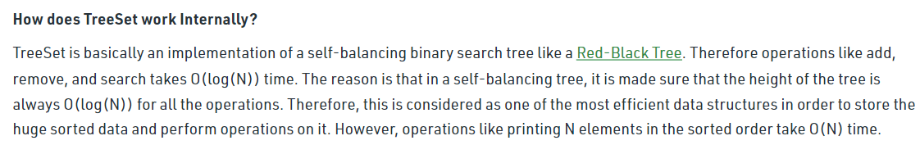

* No null value, no insertion order, sorted, no duplicate value, balanced tree-red black tree.

**What is SortedSet & Need?**

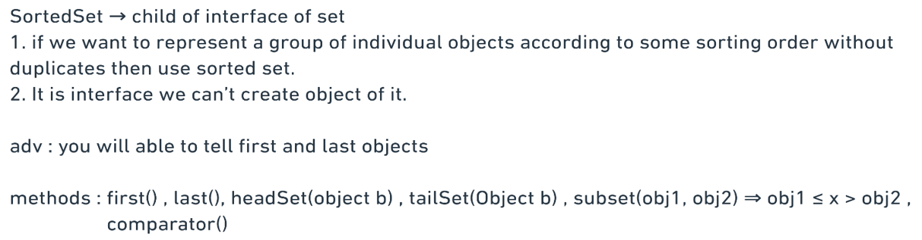

**How NavigableSet works &need?**

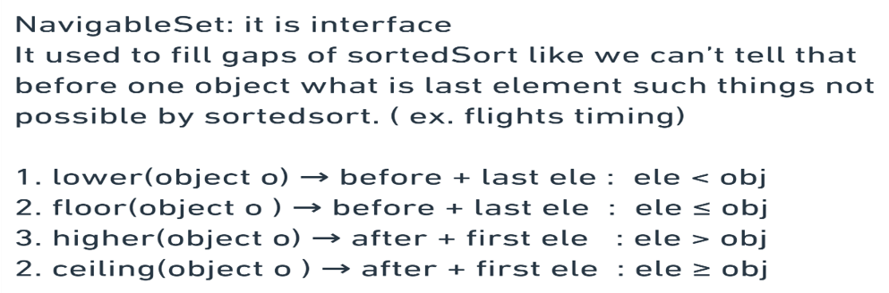

**What are similar in hash set, linked hash set, Tree set**

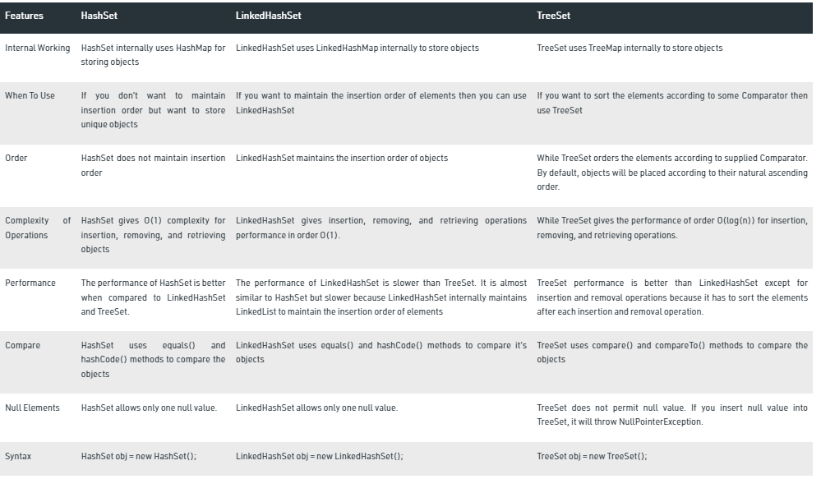

**Diff of HashMap and LinkedHashMap**

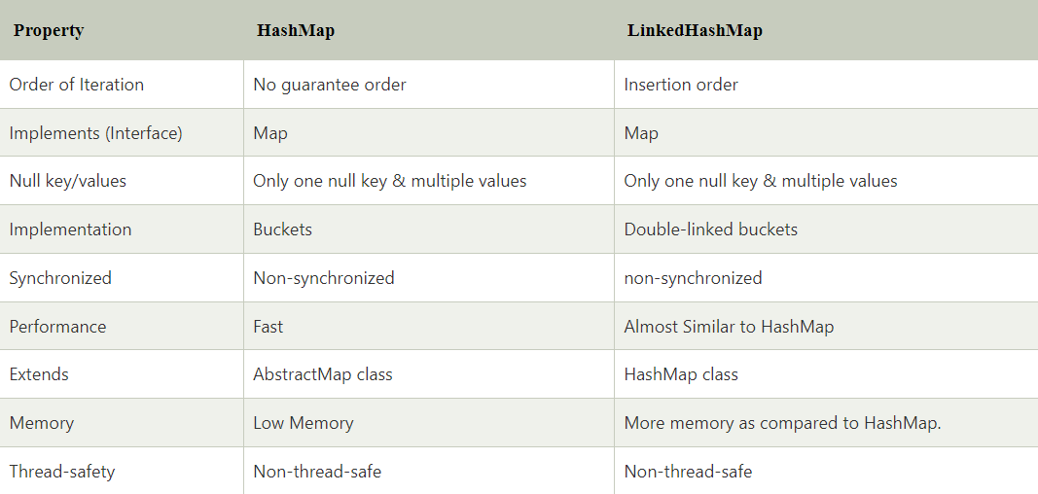**What is IdentityHash Map ?**

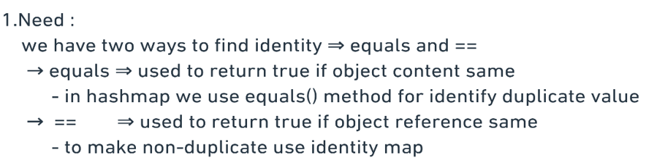

**Differences of Identity Hash Map & Hash Map?**

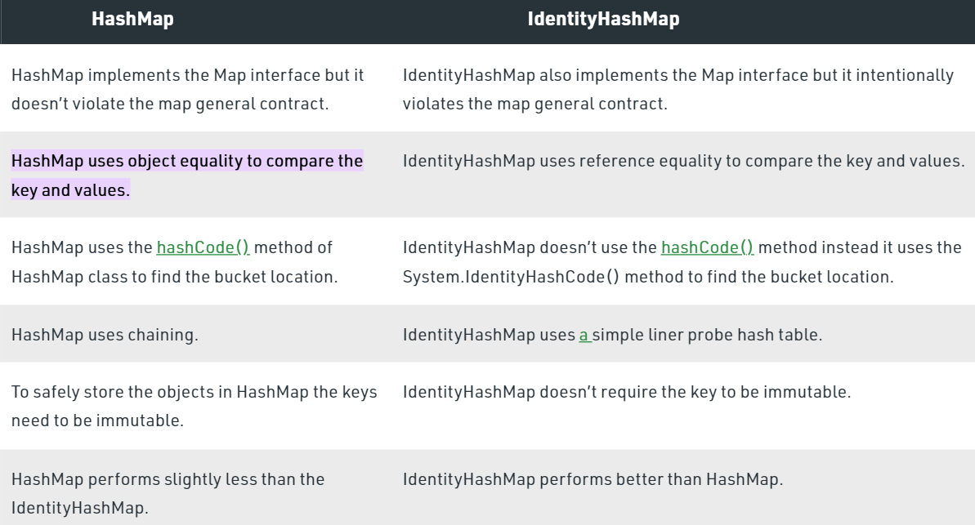

**What is Weak Hash Map?**

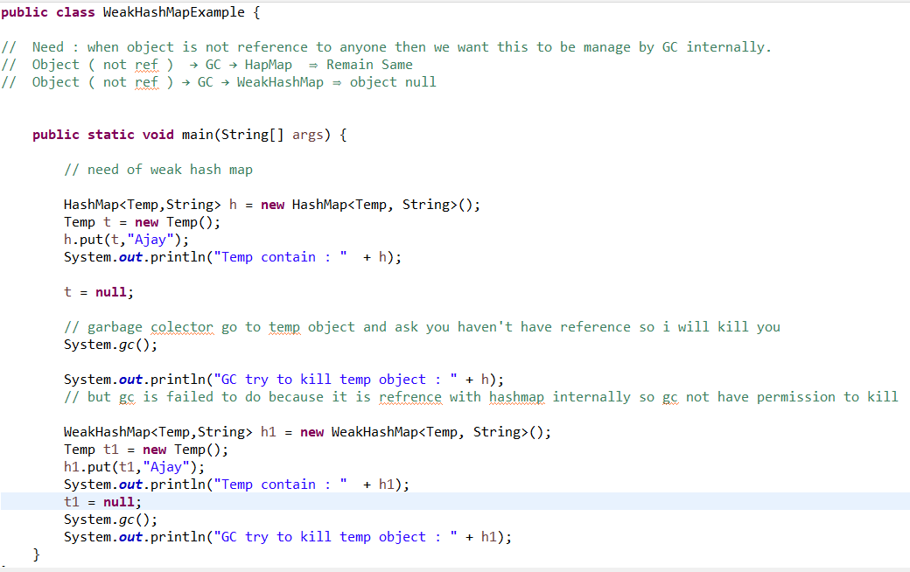

**How Sorted map work?**



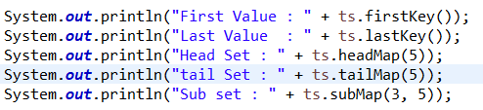

**How navigable map work?**



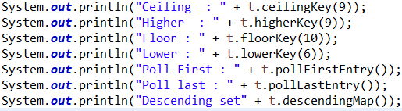

**What is differences of hash map & Linked hash map & Tree map**

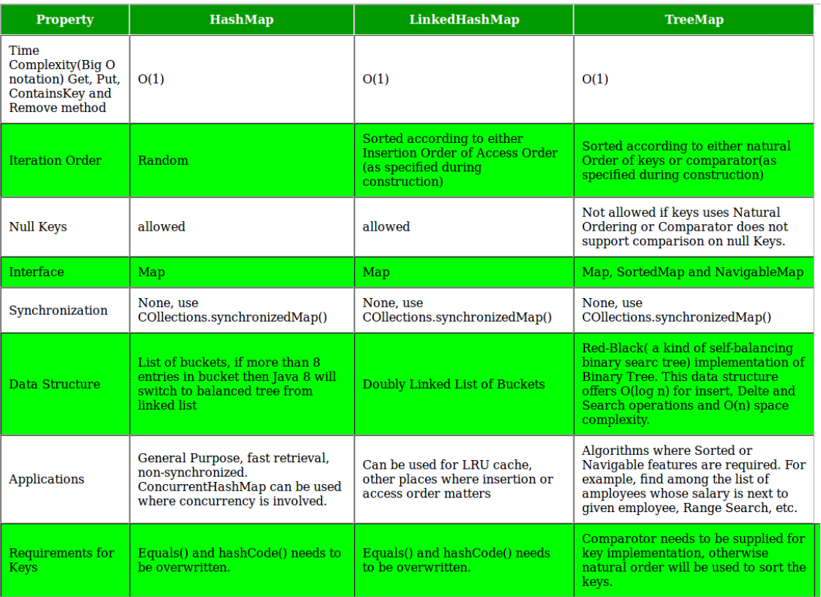

**What is queue and why use?**

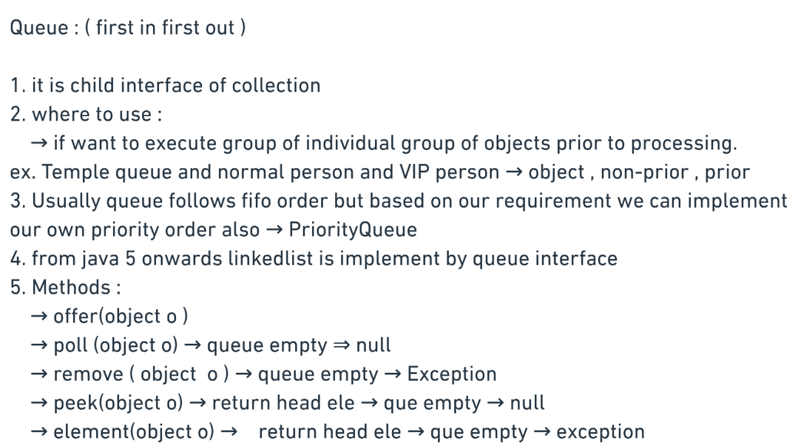

**How Deque work?**

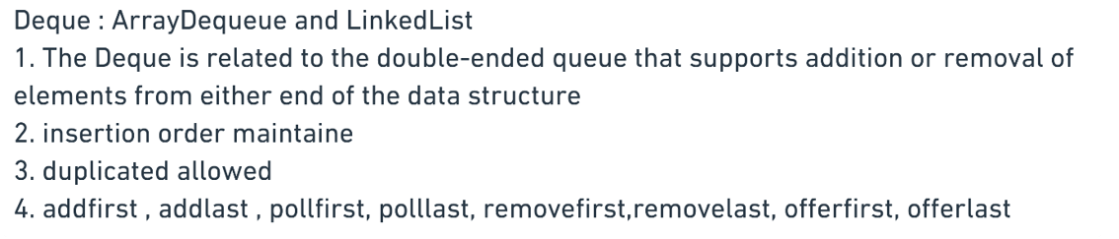

**What is Blocking Queue?**

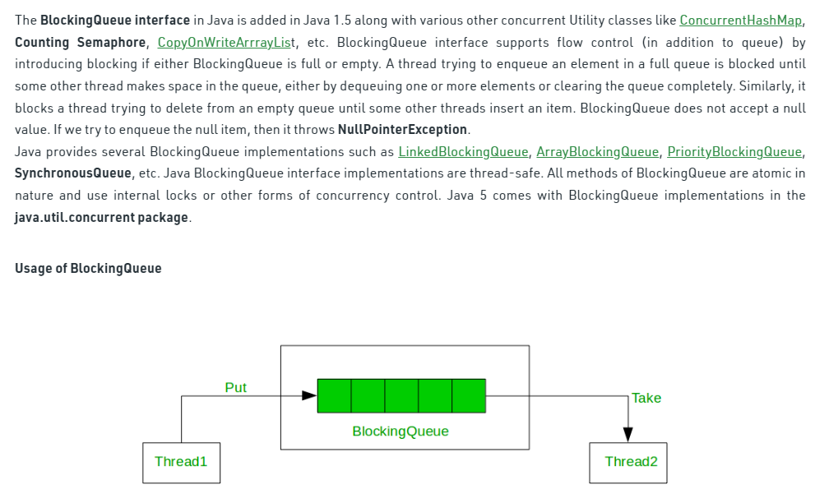

**How Hashcode and equals method works?**

